Chapter 5: Communicating nonverbally

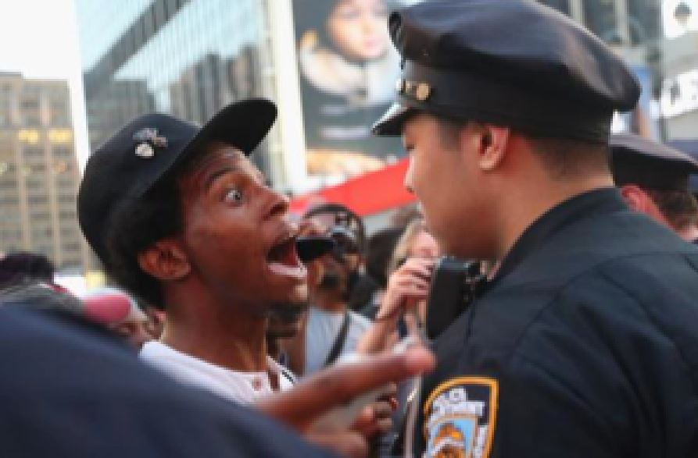
Principal learning objectives for this chapter
Successful interaction with this and associated course content will enable students to…
- Compare and contrast verbal and non-verbal codes
- Discuss nonverbal communication and provide examples across cultures
- Discuss the meaning and use of semiotics

Topics covered in this chapter…
I. Body language
- The nature of nonverbal communication
- Sending signals without words
- Gestures across cultures
- The universality of facial expressions
- Personal space
- Physically interacting with others
II. Nonverbal messaging
- Paralanguage: Conveying meaning through ways of speaking
- Managing conversations
- Physical appearance and dress
- Nonverbal expectancy violation theory
- Music: Another way to communicate nonverbally
Technically speaking: Semiotics and the Internet
In 2015, the "Boston bomber", Dzhokhar Tsarnaev, was sentenced to death. He and his brother had placed bombs near the finish line of the Boston Marathon, resulting in multiple deaths and injuries. At the trial, his involvement in setting the bombs was not at issue; he admitted his guilt. The question was if he would be sentenced to life in prison or to death. That decision rested with the jury and their perception of Tsarnaev. Character witnesses, family members, and bombing survivors testified. The defense tried to make the case that he was acting under the controlling influence of his older brother. The prosecution portrayed him as a heartless terrorist. A key factor for the jury was to evaluate Tsarnaev's character. His body language during the trial was not helpful to the defense. He seemed uninvolved and bored. He showed no emotional reaction to the horrific scenes and stories from the bombing shown and narrated in court. He didn't look at the jury or make eye contact with those on the witness stand. In mainstream US culture, an averted gaze could be interpreted as an admission of guilt and shame, while the lack of emotional response points to an absence of remorse. The jury was also shown a picture from a surveillance camera in jail in which Tsarnaev held up his middle finger in a gesture of defiance and hostility. The jury also was given the text of tweets Tsarnaev had sent, as well as the anti-US manifesto he had written on the side of the boat where he was captured. The messages no doubt condemned him in the eyes of the jury, but certainly his bearing in court contributed to the jury's ultimate decision. Nonverbal signals rarely decide life or death, but they do play a central role in human communication. In this unit we will be examining how that plays out in cross-cultural communication.
Tsarnaev, from a jail surveillance camera

The nature of nonverbal communication
Nonverbal communication can take many different forms and can vary significantly in its manifestations and usage across cultures. Its relation to verbal communication is complex. Verbal language is based on abstract symbols, arbitrarily designated to represent objects or concepts. There's no inherent, logical connection between "cat" or (or the German Katze or Chinese猫) and the feline animal. We learn the significance of the symbols over time. In contrast, much of nonverbal communication involves signs or signals that are natural and often involuntary. Smiling or frowning, for example, are not learned behaviors but naturally occurring human actions. This is not the case for on all nonverbal communication; gestures for greetings or insults, for example, are symbolic and cultural. Verbal language can be analyzed and described by a set of rules. For nonverbal communication there are unwritten rules and conventions but no formal grammar or syntax. The rules for nonverbal communication are learned informally through socialization.
Gestures or facial expressions can send messages independent of language. In fact, in some contexts, those messages (i.e., anger, joy) can be transmitted more effectively by nonverbal means. That includes vocal qualities, such as the tone of voice or actions such as crying or laughing. Often nonverbal communication accompanies speech. In such cases, the relationship between the two can vary. Body language can reinforce or emphasize the verbal message – smiling, for example, while complementing someone. Gestures can also substitute for speech – nodding or shaking the head for yes or no. On occasion, nonverbal gestures might repeat verbal messages, as in giving directions, through pointing to the way to go.
Sometimes words are not needed, as the body language here shows
Sometimes, a person's nonverbal message might contradict what is said. A person appearing downcast might respond "Oh, nothing," in response to the question "What's the matter?", but the body language may send a different signal. In such situations, the nonverbal action is likely to be perceived as the authentic message, not the stock verbal response. Nonverbal communication is seen as more honest and revealing in that it is often instinctive and unconscious. Recent research in nonverbal communication (Montepare 2003; Patterson, 2003) has demonstrated that some nonverbal behaviors fulfill universal human social needs and contribute to social cohesion and bonding. Widely used nonverbal behaviors can help identify in-group membership.
It is likely that most individuals would be surprised to learn how important nonverbal behavior is in conveying messages during conversations. The common perception is that what we are mostly paying attention to are the words being said. We tend to be unaware of the many other factors that can impact the nature of a verbal interaction. The relative importance of nonverbal codes varies with context and culture, but some estimates of what weight is conveyed by nonverbal versus verbal means gives a much higher percentage to nonverbal. Albert Mehrabian (1971) asserted that we develop our attitude towards the other person (like or dislike) overwhelmingly through nonverbal means. In fact, he claimed that 93% of that process happens nonverbally, through vocal tone and gestures (38% and 55% respectively), rather than through the literal meaning of the words (7%). The important role that nonverbals play in communicating across cultures is demonstrated in the fact that the study of intercultural communication originated with investigations into the "silent language" and "hidden dimensions" of time and space in communication (titles of seminal books by Edward Hall, 1959, 1966). One might question Mehrabian's formula as it applies to individual conversations and particular cultures. One can imagine conversations, for example, in a doctor's office or in a school, in which the essence of the communication and the affective impact are carried substantially by language. Given the importance and ubiquity of written digital messaging, contemporary communication is often electronically mediated and occurs with no nonverbal codes, except for emoji or embedded media.

Sending signals without words
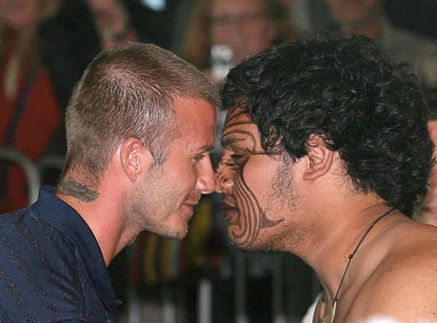
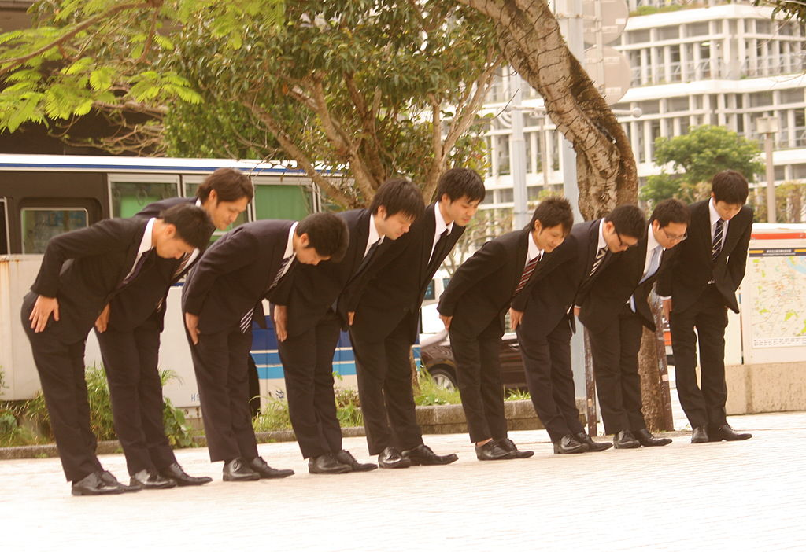
There are a number of human interactions which occur largely without the use of language or in which language plays a clearly secondary role. That's the case in rituals, a clearly defined set of actions performed on particular occasions and having symbolic significance. Greetings and departures, for example, have rituals that are largely nonverbal, such as shaking hands or waving. These tend to vary across cultures. In Japan, for example, it is common to bow when greeting someone, with the nature of the bow (how deep and how long) being determined by the nature of the occasion and social connection of the persons involved. In some cultures, kissing on the cheek is the usual greeting, although how many times the kisses are exchanged and which sexes are included can vary. In other parts of the world there may be hugs and kisses, depending on the context and relationship. In Arab countries it is common to bow and touch the forehead and chest (the salaam) when meeting someone. The Wai is used in Thailand and in other Asian cultures, consisting of a bow with the palms pressed together. In other cultures, people rub noses, such as in the hongi, a traditional greeting of the Maori people in New Zealand. Knowledge of such rituals can be helpful in avoiding awkwardness in first encounters.
David Beckham receives a hongi
The bow is common in Japan as a greeting and is used in other contexts, such as apologies
Nonverbal signals come not just from body movements such as handshaking or bowing but also through the presence (or absence) of personal objects or artifacts. Those may be articles of clothing, jewelry or accessories we wear or hold, or might be physical items surrounding us. Signals may be sent by more intangible means such as smell or sound. There may be a complex array of nonverbal factors at play, as in this example of nonverbal behavior at a military checkpoint:
A Sunni driver coming up to a security post he believes is under Shia control should not only have the right ID to hand, but should also push in a tape playing Shia religious songs and turn up the volume. He should hang a picture of Imam Ali, the son-in-law of the Prophet Muhammad and the most revered figure in the Shia faith, from the rear-view mirror. He might also slip on the large silver ring worn only by Shias, especially those considered to be descendants of the Prophet, and perhaps carry a “torba”, the round piece of clay that Shias often place on their foreheads when they bow down in prayer. These and other handy tips are given on the Iraqi Rabita website, designed to advise Sunnis on how to get through Shia checkpoints (Checkpoints, 2007).
The situation is not likely one most of us will ever encounter, but it dramatizes the importance of nonverbal codes in particular contexts. In such situations, nonverbals can play a significant role in easing tensions. On the other hand, inappropriate nonverbal behavior can easily have the opposite effect, exacerbating potential tensions and causing open conflict.

Gestures across cultures
One of the areas in which there is considerable cultural variation is in the use of gestures and body movements. This area of communication is called kinesics, with the two main kinds of actions labeled emblems and illustrators (Ekman & Frieden, 1969). Emblems are hand gestures that have by themselves a direct meaning, such as insult gestures like the raised middle finger. Illustrators are hand or arm gestures that accompany speech and which accentuate or complement what is said. Pounding a podium with one's fist while giving a speech is an example of an illustrator. Emblems and illustrators are used for a variety of social functions, such as greeting, leave-taking, providing directions/commands, or issuing warnings. Being aware of cultural differences in this area can be important in cross-cultural encounters.
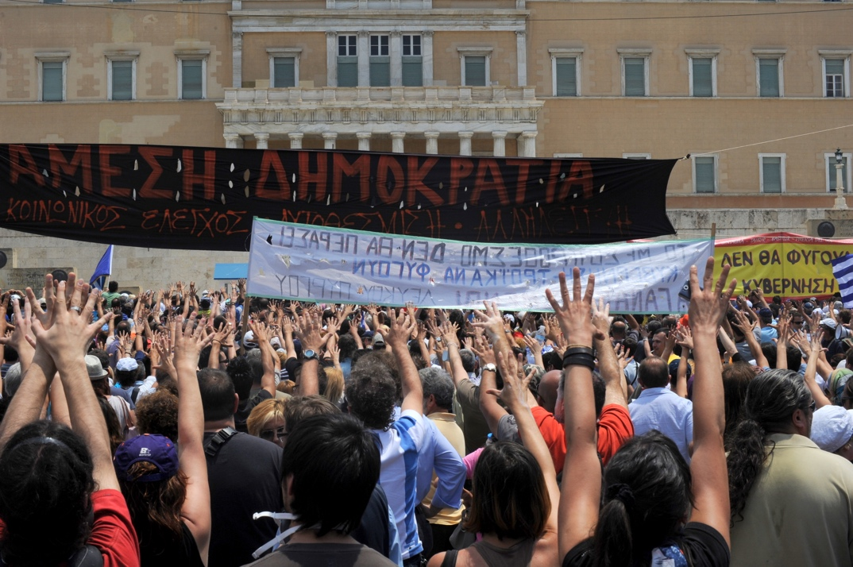
One of the richest array of gestures are for communicating insults and obscenities. Insult gestures tend to vary across cultures and are different as well in the extent to which they are used. In Greece, for example, the mountza (μούντζα) or moutza (μούτζα) is a commonly seen insult gesture. It consists of spreading the fingers (one hand or both) and trusting them outwards, towards the other person (as if flinging something unpleasant). In other cultures, the arm-thrust (bras d'honneur) is used, forging a fist and slapping it upwards under the biceps of the arm. Such gestures can be highly offensive and are often considered obscene. Other gestures may convey skepticism or disbelief, such as the French mon oeil (my eye), using a finger to pull down the lower eyelid. The gesture is also used in Japan, known as the Akanbe (あかんべえ).
Moutza against the parliament by Greek protesters
Akanbe gesture in Japan
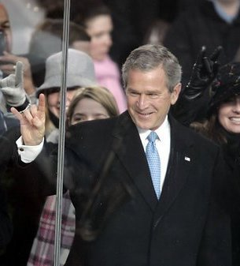
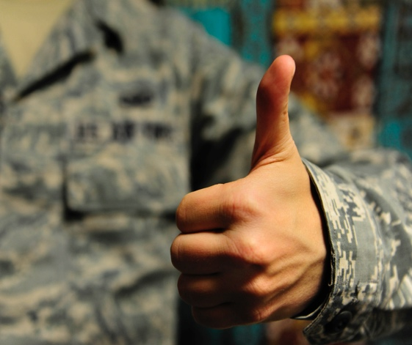
The caution in using gestures extends to those which may be widespread in a culture, and which we may interpret as universal. The North American A-OK sign (circled thumb and pointer finger, with the other fingers spread out) is an obscene gesture in many European cultures. Likewise, the inverted peace sign – two fingers facing inwards is an insult in England and Australia. The thumbs-up gesture signals in North America well done; in Greece and other countries, it is equivalent to the insulting "Up yours!" (Cotton, 2013). US President George W. Bush famously used the hook ‘em horns gesture of the Texas Longhorn football team to signal his approval of the marching band of the University of Texas. In Italy, that gesture is well-known, but it doesn't signal fan enthusiasm or let's rock. It is called il cornuto, indicating that the other person is a cuckold, that is, that his wife is cheating on him (Cotton, 2013).
US President George Bush
Thumbs-up may be an insult
Pointing with the forefinger is a gesture North Americans frequently use. Using that gesture to point at people is in some cultures extremely rude. Likewise, the beckoning gesture with palm turned upward and extending one finger or the whole hand is considered an insult in Japan and other countries. There are a variety of beckoning gestures, In Afghanistan and the Philippines, for example, one motions downward with the palm of the hand facing the ground (Cotton, 2013). Emblems have traditionally been culture-specific. However, the forces of globalization and technology have exposed people worldwide to gestures used in popular media (Matsumoto & Hwang, 2012). Through the greater availability globally of North American television shows and movies, as well as the popularity of social media such as Facebook and YouTube, some North American gestures, such as those for greeting and departure, have become familiar in many other cultures. (Jackson, 2014).
Another kind of gesture is an adaptor, a kinetic action used to satisfy a psychological or physical need, such as tapping one's feet or playing with a pen. Some are learned behaviors, such as covering one's mouth when sneezing, while others, such as scratching, are automatic or biological. Most do not affect communication, as they are not intended to send a message. However, some are considered rude in particular cultures; examples are: "never chew gum in public in France; whistling under any circumstances in India is considered impolite; pointing a finger in the Arab world is considered a rude gesture; and winking may be considered an insult or a sexual proposition in India and Pakistan" (Ting-Tooney, 1999, p. 126). Using adaptors in the wrong context or at the wrong time can be awkward or embarrassing.

The universality of facial expressions
Some cultures tend to be much more expressive and rich in their use of body language than others. Italians and Mediterraneans in general are normally placed in that category, while northern Europeans and Asians are seen as more restrained in their use of gestures. It is often claimed that facial expressions – called affects displays – tend to be universal, the idea being that expressing basic emotions is an elemental, instinctive behavior common to all humans. This idea goes back to Charles Darwin (1872) who claimed all humans express emotion in the same way. This was later contradicted by anthropologists such as Margaret Mead (1975). It wasn't until the 1960s that so-called "universality studies" were conducted by Paul Ekman and others. In a series of experiments involving participants from a variety of cultures, they showed that there were six universal expressions — anger, disgust, fear, sadness, happiness, and surprise (Ekman, 1972). Later, a seventh expression, contempt, was added (Ekman & Heider, 1988). As the studies involved people from industrialized countries, who may have learned to interpret faces from mass media, other studies were conducted among tribal groups in New Guinea, which came to similar results (Ekman & Friesen, 1971). An interesting experiment conducted with blind athletes produced the same results as their sighted colleagues (Matsumoto & Willingham, 2009). Because the blind athletes could not have learned the behaviors, one can assume there is an innate capacity to display facial expressions.
Joy is expressed the same across cultures
What causes particular emotions and determines their intensity can be quite different, both personally and culturally. It is also the case that in many contexts we are able to assert control over our expressions. Codes of general conduct, politeness, or social harmony may influence the public display of emotions. This was shown in a cross-cultural experiment (Matsumoto & Ekman, 1989), which studied expressions of Japanese and US students while watching emotionally disturbing films. When both groups of young people were among themselves, they showed the same expressions. However, when the Japanese students were with an older, male observer, they displayed neutral expressions or even smiled, while the US students continued to display the same negative emotions. Ekman and Friesen (1969) coined the term cultural display rules to describe such cultural differences in facial expressions. The concept explains the difference in expressions of the Japanese students in the experiment, as due to the cultural mandate in Japan of managing and minimizing expressions of feelings in the presence of a third party. In Japan it is culturally appropriate to hide unhappiness by smiling or embarrassment by laughing. While weeping in public is considered in Japan to be inappropriate, in Middle Eastern or Latin American cultures it is normal to express one's emotions openly and visibly.
Using the concept of cultural display rules, Matsumoto (1990) developed a theory of the expression of emotions that incorporates Hofstede's taxonomies, particularly as they relate to individualism versus collectivism. According to the theory, because individualistic cultures encourage and reward self-expression, individuals in those cultures are free to express fully and instinctively their feelings, whether they be positive or negative. On the other hand, those in collectivistic cultures are bound by conventions of the collective good and social harmony to regulate their expression of emotion when not alone. Matsumoto also incorporates the concept of power distance:
High power-distance cultures endorse displays of emotion that reinforce hierarchical relations (i.e., status reminders), such as showing anger toward a low-status person or appeasing a high-status person (e.g., smiling). Low power-distance cultures embrace egalitarian values and teach the importance of treating people as equals. Thus, there is less pressure in these cultures for members to adjust displays of emotion according to the status of another person. (Remland et al., 2014)
High power distance cultures tend also to be labeled collectivistic; that would include most Middle-Eastern, Latin American, African and southern European countries. Low power/individualistic cultures are considered to be South Africa, North America, Australia, and northern Europe (Hofstede, 1980). As always, in such broad-stroke generalizations, caution is needed in applying these labels to individuals. While dominant cultural forces may be powerful, they may be contradicted and potentially negated by values associated with group membership, whether those be ethnic, regional, or other. It is also the case that individual personalities play a significant role in the degree to which emotions are displayed or suppressed. The patterns we've identified in nonverbal behavior should be seen as examples not as absolutes. Being aware of such potential variations can be helpful in adjusting expectations and suspending judgments.

Personal space
One of the actions which can affect the course of the conversation is for one or the other of the conversants to move closer or further away. Edward Hall (1966) pioneered the study of proxemics, the perception and use of physical space, including territoriality and personal space. Territoriality refers to the actual physical space, while personal space is perceptual or psychological – the kind of space bubble that we perceive around us. Following complaints from both Arab and US students in a North American university setting, O.M. Watson (1970) investigated the nonverbal behavior of the two groups. He found that the US students viewed the Arabs as pushy and rude, while the Arabs considered the US students to be distant and rude. He discovered that a substantial part of the problem were different conceptions of personal space, with the US students feeling the Arab students were invading their bubbles and the Arab students seeing the US students as unfriendly because they were keeping their distance. Hall (1966) developed a four-level classification of social distance. For the US, he defined intimate space, reserved for highly personal relationships, as 9 to 18 inches (23 to 45 cm), and personal distance ("arm's length") at 1.5 to 4 feet (.5 to 1.2 m), the normal spacing for conversations. Social distance he established at between 4 and 12 feet (1.2 to 3.6 m), the spacing normal in casual gathering and work environments. Public distance he defined as being 12 feet (3.6 m) or longer, used for public speaking or large gatherings. Researchers have identified particular cultures as "high contact", meaning that there is a preference for a closer proximity and a high degree of physical contact (Aiello, 1987). Examples frequently given are Arabs, Latin Americans, and southern Europeans, who all tend to use closer interaction distances then in so-called low contact cultures (USA, northern Europe, Australia). There are other factors besides regional culture which may affect personal distance, such as gender, age, ethnicity, or topic of conversation.
In some cultures, people like to keep their distance
The smell of roses seems universally positive
Personal distance is sometimes associated with smell. The study of smell in humans is called olfactics. In some cultures (in Africa and the Middle East, for example) there's a preference for standing close enough to a person in conversation to be able to detect body odor. Odor is used in such cases to categorize people according to status, power, or social class. In many cultures wearing an expensive perfume or cologne can signal status and wealth. On the other hand, the smell of sweat or strong body odor is likely to suggest manual labor and lower social status. Some smells are associated with particular ethnic groups and may lead to prejudicial treatment. The smell of curry, linked to South Asians, has been used as a basis for discrimination, such as refusing to rent apartments to Indians or Pakistani (Jackson, 2014). Although some smells seem to be universally attractive (jasmine, lavender, roses) others may vary in how they are perceived across cultures. The smell of onions, for example, is considered unpleasant in many cultures, but the Dagon people of Mali find the smell attractive, even to the point of rubbing onions on their bodies (Neuliep, 2006).

Physically interacting with others
There are also cultural conventions related to if and how the conversation partner should be touched. This area of nonverbal communication, tactile communication or the use of touch, is known as haptics. Touch conventions vary significantly across cultures and are dependent as well on age, gender, and relationship. In some Arab cultures, it is common for men to hold hands in particular situations. Some cultures have a taboo on touching the top of someone's head, as in patting a child, as the head is considered sacred. Another taboo, in India, the Middle East, and Africa, is the use of the left hand in certain social situations, such as eating. Cooper, Calloway-Thomas & Simonds (2007) provide a set of rules in relation to touch in Thai culture:
- Don’t touch anyone’s head for any reason. The head is the most important part of the body. It is the seat of the soul.
- Do not touch a female on any part of her body.
- The feet are considered the “dirtiest” part of the body. They are used only for walking. Thus, it is an insult to rest your feet on someone else’s backrest, such as in the cinema or on a train.
- Women must never touch a monk or his robe. Even in a bus or train, Women cannot sit next to a monk.
- Always accept things with your right hand. The left hand is used to Wash the posterior and is therefore regarded as unclean (p. 138).
Being aware of such taboos in visiting another culture can make seemingly strange behavior understandable and help to avoid embarrassing faux-pas.
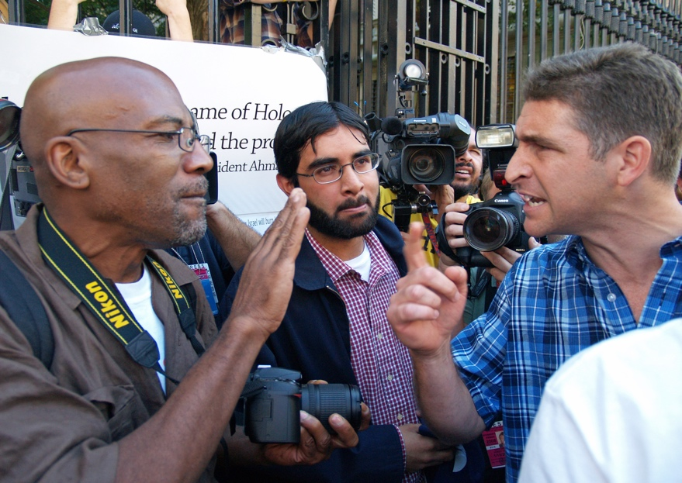
Eye contact is often included as a topic within proxemics as it tends to regulate interpersonal distance. Direct eye contact tends to shorten the sense of distance, while an averted gaze increases it. In many cultures, such as in many Asian countries, avoiding eye contact conveys respect. In some situations, making eye contact communicates that one is paying attention. Breaking off eye contact can be a signal of disinterest or even rudeness. Within the US, different ethnic groups have been found to follow different norms in the use of eye contact to regulate conversations. African-Americans maintain eye contact when speaking but avert their gaze when listening, but just the opposite is true for European Americans (LaFrance & Mayo, 1978). This distinction can lead to conflict:
Groups may have different expectations in maintaining eye contact in conversations
Interethnic expectancy violations exist when African Americans expect the European Americans to look them in the eyes when speaking but instead receive “non-responsiveness” or “indifference” cues. European Americans, on the other hand, may view the direct eye gaze during speaking as “confrontational” or “aggressive” (Ting-Toomey, 1999, p.126).
In both pluralistic societies and in cross-cultural encounters, being mindful of variations in this area is important. Nora Dresser's book, Multicultural Matters (2005), chronicles how Korean-American shopkeepers, who did not make eye contact with their customers, were perceived as disrespectful, something contributing to the open confrontation taking place in US urban centers between some Asians and African-Americans. In some contexts in the US, such as in urban areas among teens and young adults, looking directly at someone can be seen as a provocation, reflected in the term "mad-dogging" (Remland et al., 2015).

Paralanguage: Conveying meaning through ways of speaking
Body language is important in sending signals during conversations. So-called regulators are nonverbal actions or behaviors which serve to direct or manage conversations. Of significant importance in cross-cultural communication are aspects of paralanguage, such as tone of voice, rate of speech, or loudness. Tone and intonation can have a determining effect on the message conveyed, turning a statement, for example, into a sarcastic comment. The volume, fluency, or rhythm of speech can transmit to the listener information such as degree of confidence, nervousness, or even perceived trustworthiness of the speaker. Our cultural backgrounds tend to lead us to make assumptions about another person's intentions or feelings based on paralinguistic clues. Harry Triandis (1994) provides a dramatic example of misinterpreting vocal clues:
In January, 1991, James Baker, then the United States Secretary of State, met with Tariq Aziz, the Foreign Minister of Iraq. They met in an effort to reach an agreement that would prevent a war. Also present in the room was the half-brother of Saddam Hussein, whose role included frequent calls to Hussein with updates on the talks. Baker stated, in his standard calm manner, that the US. would attack if Iraq did not move out of Kuwait. Hussein ’s half-brother heard these words and reported that “The Americans will not attack. They are weak. They are calm. They are not angry. They are only talking.” Six days later Iraq saw Desert Storm and the loss of about 175,000 of their citizens. Triandis argued that Iraqis attend to how something is said more than what is said. He further suggests that if Baker had pounded the table, yelled, and shown outward signs of anger, the outcome may have been entirely different (Martin & Nakayama, 2010, p. 277).
The voice qualities of a speaker can be as important in conveying a message as the semantic value of the words spoken. If someone is articulate and coherent, we tend to form a favorable impression, leading to an instinctive feeling that the person is trustworthy. If someone is hesitant and imprecise in speech, we may gain an unfavorable opinion, no matter what it is that the person says. Scholars who engage in conversation analysis have shown even slight modifications in voice tone or intonation can send a message to the listener. John Gumperz (1982), for example, provides a number of examples of misunderstanding between Indians speaking English and native Britons due to prosody, or the vocalic shaping of utterances, including pitch, volume, and tempo.
One of the phenomena that contributes to managing conversation are vocalizations, sounds that do not carry on their own any meaning. These might be fillers or vocalized pauses, such as "er" or "uh-huh" in English or "Este…" in Spanish. Often they are used as conversational backchannels, indicating to the speaker that we are listening. In some cases, vocal regulators may be misinterpreted in cross-cultural contexts. The Japanese filler hai hai is often used by natives in the meaning of "I hear you", but given that hai literally means "yes" there may be misunderstanding in a non-native assuming a positive affirmation, rather than merely an acknowledgement of having heard the speaker. Vocalizations may also provide guidance in turn-taking or indicate that a listener is ready to move on to another topic.

Managing conversations
One of the role vocalizations play is to function as a backchannel in conversations, a way for a listener to send messages to the speaker (Yngve, 1970). This may consist in English o sounds such as "uh-huh" or "hmm", or words and phrases like "yes" or "go on". Backchannel responses play different roles; they may encourage the speaker to continue, indicate the extent of interest, or assess the speaker's statements, i.e., agreeing ("Right”) or expressing doubt ("Do you really think so?”). There may be more than simple words or phrases involved, namely longer utterances completing the speaker's sentences, requesting clarification, or attempting to take the floor. Background communication occurs across cultures, but may vary in norms and expectations, which can cause confusion or awkwardness.
How conversations flow varies with culture and context. In situations in which a strict hierarchy is present or when the interaction is highly formal, there may be fixed patterns for managing a conversation and signaling when it is over. In such situations, interrupting a speaker may be inappropriate. There are conversational norms which may play a role. In particular cultures, it is common, even expected, for others to interrupt a speaker frequently. In France, for example, this is seen as part of what constitutes a good conversation.
[Interruptions] signal interest in the other’s remark, which merits a commentary, a word of appreciation, denial, protest, or laughter–in short, a reaction without which the remark would ‘fall flat.’ The ball is tossed to be caught and tossed back. Where there is no ‘interruption,’ when each person speaks sedately in turn (as in American conversation, according to the French), the conversation never ‘takes off’; it remains polite, formal, cold (Carroll, 1988, p. 37).
While this kind of spontaneity and frequent back-and-forth is seen by the French (and in other cultures) as stimulating, it may be seen by some as chaotic or rude.
Some paralinguistic behaviors are instinctive, others are learned. South Koreans, for example, are socialized into avoiding loud speaking or laughing in public. In some cultures, the use of silence can be an important aspect of communication. In the US, long pauses in conversations are awkward. In Finland and in some Asian cultures, silence is valued as offering time for thought or reflection, or as a sign of respect, allowing time for the interlocutor to finish. In his ethnographic study of the Western Apache Native American tribe, Keith Basso (1970) reported that silence was used for "unscripted" social situations, such as unforeseen encounters, talking with strangers, first dates, times of mourning, or greeting those who had been away for an extended period of time. Later, Charles Braithwaite (1999) expanded the study of the role of silence to a variety of cultures, in which silence tends to be part of the communicative pattern. He confirmed Basso's findings that silence is seen in communication situations in which there is uncertainty, ambiguity, or unpredictability. He also found that silence is often used in conversations in which the participants represent different positions of power or authority.
One of the aspects of speech which affect listener perception is the speaker's accent. Non-native accents can often stigmatize the speaker, evoking stereotypes associated with social class, ethnic background, economic status, or level of education. In some cases, a particular accent, such as a British accent in the US, is perceived positively. In most cases, however, accents are perceived negatively and may have real-world consequences for the speaker in terms of discrimination in personal encounters or institutional settings.

Physical appearance and dress
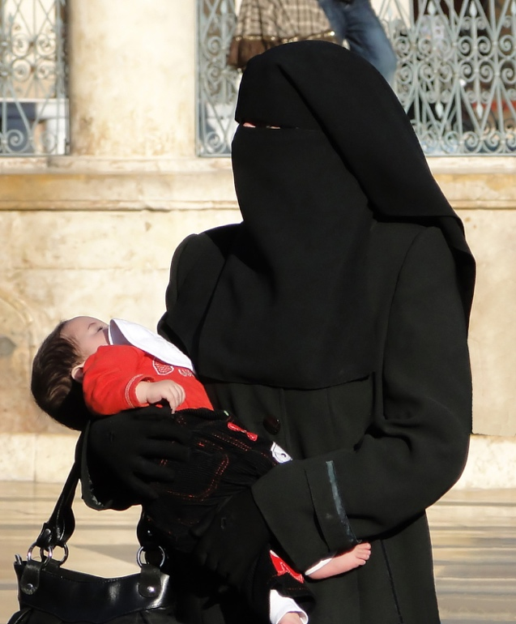
One of the important nonverbal signals all humans send comes through our appearance, i.e. how we dress, arrange our hair, or use body art. Many cultures have rules and conventions for dress and appearance, established through custom or religious beliefs. Women in Muslim countries, for example, dress so that their hair is covered and, in some cases, also their bodies and faces. In some cases, dress can provide information about social/economic position, marital status, or age. In Japan, women's komodos vary according to the time of year and occasion, but also based on marital status and age. For the Masai tribe in Kenya, earrings and necklaces designate the marital status of women, while men wear earrings and arm rings that show their social status, indicating whether they are elders or warriors (Vandehey, Buergh & Krueger, 1996). In rural northern India, the level of a woman's veil over her face can indicate romantic interest or disinterest (Lambert & Wood, 2005). Dress and physical appearance can be important identifiers for membership in particular groups. Members of motorcycle gangs wear black leather and heavy boots. Japanese businessmen ("salarymen") wear dark, conservative suits and plain ties. Japanese tourists often wear a resort hotel's yukata (a lightweight komodo) signaling to others in the town their role (Ting-Toomey, 1999). In this way, forms of dress serve as identity markers. Certain uniforms signal professions, as in the case of police officers or members of the military, while also conveying a sense of authority and power.
Woman wearing a niqab (veil)

Body piercings and tattoos, in bygone days, indicators of low-prestige socio-economic status (sailors, carnival workers), have become mainstream among young people in the US and elsewhere. Older people are likely to retain the images from the past and may have a negative view of heavily tattooed or pierced young people. One of the persistent stereotypes is in regards to women's dress and appearance. Young women in mini skirts and tank tops, especially if blonde, may be perceived as flighty and unintelligent. Muslim women wearing a hijab face prejudice and discrimination in many non-Muslim countries, which is even more pronounced for those wearing a whole body burqua. In some Western countries, wearing traditional Muslim female dress in public or in schools has been banned. In the US, hooded sweatshirts (hoodies) are often associated with young black men. In Florida, a young black man, Treyvon Martin, was wearing a hoodie when shot dead by a white "neighborhood watch" member as he was returning from a convenience store. The white man found Martin "suspicious", due to his skin color and attire.
Tattoos have become mainstream in many cultures
Appearance messages are generally the first nonverbal codes we process, sizing up the other person based on skin color, appearance, and clothing. The first impression might determine our attitude towards another person, helping to determine whether we want to get to know that person or not. Sometimes, some features of the other person's appearance might lead to specific pre-judgments. One of those might be the particular shade of skin. Black people with darker skin are sometimes viewed as somehow less attractive or having lower status than Blacks with lighter skin. Light-skinned Blacks may feel discriminated against as well (see sidebar). In South American countries such as Brazil, there is a rich mix of ethnicities and races, resulting in a wide range of skin colors and a complex social hierarchy, built in part on the particular shade of one's skin.
Different Shades of Black Identity
If you are a light-skinned Black person, you are looked upon as "uppity" or thinking that you’re too good. This is something I have come across a lot. For my first year of college, I attended the first historically Black college, Lincoln University. It was my first time being around that many African Americans (the high school I attended was mostly Caucasian). I am naturally shy, so I would walk around not speaking to anyone. In many cases I would walk around looking at the ground or just with no expression on my face whatsoever. I was viewed as the "uppity" light-skinned girl who thought she was too good for everyone else. - Ami
Remland et al., 2014, p. 149.

In some cases, we are conscious of the distinctive views we may have towards those with a certain appearance. Many US Americans, for example, have heard so much since 2001 about Muslims and terrorism, that someone perceived to be Muslim by their appearance and dress likely triggers already well-established and self-acknowledged views on Muslims. The largely negative stereotypes can have tragic consequences, as the acts of violence towards Muslims in the US and elsewhere has shown. In some cases, the perceived target may not even represent the intended group. The first victim of revenge killing in the US following the September 11, 2001 attacks was not a Muslim, but a Sikh gas station manager in Arizona shot down by a man vowing to kill "towel heads" (Basu, 2016).
In many cases individuals may not be aware of the negative attitudes towards others. Humans naturally tend to categorize, and that process includes grouping together other humans. We likely do that with individuals we meet without being aware of this process of implicit bias. This is a phenomenon that scientists have been studying for some time, namely that even well-meaning people have hidden prejudices against those of other races. Studies have shown subtle biases are widespread in the US, especially against Blacks, and lead to discrimination in many areas, including in education, professional life, and housing (Yudkin at al., 2016). In the US recently, the issue has arisen in connection with white police officer's using violence against unarmed young black men. Studies have shown that "implicit bias can be overcome with rational deliberation" (Yadkin & Van Bavel, 2016). Many police departments in the US have begun the process of making police officers aware of their biases. Project Implicit from Harvard university provides an online process for analyzing one's possible biases in a number of areas, including attitudes towards race, skin tone, religion, sexuality, Arab/Muslims, age, disability, and weight. These are all areas in which implicit bias may be present in individuals in the US. Other cultures are likely to have some of the same biases, along with others. In recent years, corporations in North America have begun to offer training to employees to make them aware of hidden biases in an effort to treat their customers equitably, regardless of race or ethnicity. Whether such training is effective – particularly when offered in one-time short training seminars — is questionable (Godwin-Jones, 2018).

Nonverbal expectancy violation theory
As in other areas tied to cultural values and behaviors, people develop an expectation of conformity with the conventions of the culture, in this case with the unwritten rules of nonverbal behavior. In the US, we don't expect women to wear headscarves as normal everyday attire. We do expect to shake hands upon meeting someone for the first time, which may not happen if, as a non-related man, we are meeting a Muslim woman. Such occurrences are, in the formulation of Judee Burgoon (1978), violations of nonverbal expectancy. According to this theory, people have expectations about the appropriateness of nonverbal behavior, which is learned and culturally driven. When these expectations are violated, it produces a reaction she describes as "arousal", which can be physiological or cognitive, positive or negative. Our reaction depends on the severity of the violation, the nature of the person (such as attractiveness), and the implicit message associated with the violation. The context and the person will determine our reaction. If a person standing too close at a party (thereby violating personal space) is attractive and well groomed, the reaction is likely to be quite different than if that person is perceived as slovenly and unattractive.
Reactions to violations of nonverbal codes depend as well on the nature of our communicative and cultural environment. If we are accustomed to high-context communications, we may be more dependent on nonverbal messages and are therefore more adept at decoding nonverbal behavior. In that case, for example, silence might be evaluated positively and perceived quite differently than it is in cultures where periods of silence in a conversation run counter to expectations. In intercultural communication contexts, violations of expectations by a non-native could be seen as naïve/endearing or strange/rude depending on how we view that person. Using Hofstede's cultural categories, Burgoon points out that violating norms in high uncertainty avoidance cultures is likely to be less acceptable. On the other hand, countries with lower power distance may be more flexible in terms of rules about verbal and nonverbal behaviors.
In the South Asian countries, sitting with one’s back towards someone older in age or authority, or having the soles of one’s feet face someone older in age or stature or authority, or books – the source of knowledge, or the altar, is considered very rude (Malik, personal communication, September 18, 2017). That is the reason why one is unlikely to find book shelves or altars at the feet of the bed or against or on the wall facing the feet of the bed. It is also considered inappropriate to have an altar or, occasionaly, the photographs of one’s ancestors in a bedroom that is likely to be used as a conjugal bedroom.
One of the cultural norms that may lead to adverse reactions is the public display of affection. In most Western cultures, there has long been acceptance of heterosexual couples touching and kissing in public. The degree to which this occurs differs. Researchers have found that this is more common, for example, among French and Italian young couples than in the US (Field, 1999; DiBiase & Gunnoe, 2004). Acceptance of homosexual couples is widespread today in many Western countries, but not in many other parts of the world. In most Muslim cultures, the strict separation of unmarried people disallows even heterosexual contact in public. In India, some public displays of affection are taboo. In 2007, US actor Richard Gere faced widespread condemnation in India, after kissing Indian actress Shilpa Shetty at a televised fund-raising event. A photo of the kiss made front-page news across India, and effigies and photos of both Gere and Shetty were burned. An Indian court issued an arrest warrant for Gere, as he had "transgressed all limits of vulgarity" (Indian Court, 2007).
Richard Gere kisses Shilpa Shetty
It is of course not possible to know all the ins and outs of nonverbal transgressions in every country. On the other hand, it is certainly possible to be informed about the cultural practices in countries which we plan to visit or among local communities with whom we are likely to have contact. To the extent possible, we should act in accordance with the cultural expectations. That might mean taking off shoes before entering a home, or dressing more modestly then we would normally. On the other hand, we may oppose particular practices for religious, political, or philosophical reasons, and consciously refuse to adapt to local customs. That might mean, for example, women not accepting the prescribed cultural role in behavior, bearing, or dress expected in a particular culture. In general, it is good practice to anticipate nonverbal expectations to the degree possible. Even if we don't know the specifics of expectations in a given culture, we can certainly observe and learn. Burgoon's theory suggests that if we are well-intentioned, yet unaware of specific practices, it is likely others will be lenient in overlooking transgressions. In fact, it may be that expectations for foreigners in this regard are different than they are for natives. Koreans, for example, would likely not expect foreigners be familiar with the intricacies of bowing as they interface with Korean social hierarchies.

Music: Another way to communicate nonverbally
Music is a "universal language" in that it is understood without the need for language. Music plays many different roles in human society – entertaining, comforting, inspiring, socializing, and more. It can bring people together (anthems, concert venues, singing together, celebratory music) or pull them apart (protest songs, generational differences in taste, distasteful/hateful lyrics). Two examples from Germany illustrate that contrast. The Horst Wessel Lied was the anthem of Nazi Germany, celebrating violence and hatred. Beethoven's Ode to Joy (the last movement of the 9th Symphony, based on a poem by Friedrich Schiller) has been adopted as the unofficial anthem of the European Union. It celebrates brotherhood and solidarity. Our interest here is in music as a marker of cultural identity and as a non-verbal form of contact and communication across cultures.
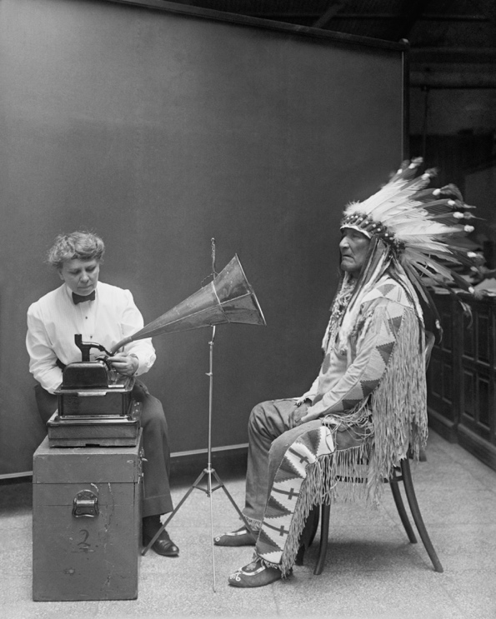
Ethnomusicology is the study of music in cultural context. Like intercultural communication, the field involves contributions from many different disciplines. From the beginning, a major focus has been on non-Western music, with many practitioners engaged in ethnographic fieldwork. That involves learning about and documenting the music, language, and cultural practices of underrepresented ethnic groups. One of the pioneers of this field was Alan Lomax, who recorded folk music in the US and Europe in the 1940s and 1950s. His work contributed to the folk music revival of that time. Today, there are efforts underway to preserve endangered indigenous music traditions, just as there are to save languages from extinction. Catherine Grant's book, Music Endangerment (2004) chronicles some of those efforts.
Recording Blackfoot chief Mountain Chief in 1916
In recent decades, ethnomusicologists have been particularly interested in the effects of globalization on music traditions worldwide. The popularity of rock 'n' roll music in the late 20th century, for example, spread not only the English language worldwide, but also particular values and practices of Anglo-American youth culture. Globalization has resulted in the development of many hybridized musical forms. Traditional folk music in many parts of the world, and among diaspora communities, is often mixed with modern musical genres, resulting in new musical and cultural mixes. Immigrant communities will often have complex music practices. Young people are likely to listen to mainstream popular music but also be exposed to traditional music of their culture by way of religious, celebratory, or family events. Older members of the community may try to maintain a "pure" musical tradition as a means to maintain their culture within an encompassing foreign culture with different values and language.
Fock (1997) examines the complexity of such an immigrant community in the case of Turks in Copenhagen, Denmark. She chronicles how Turkish music is viewed differently when heard in different locales. If played in a Turkish restaurant, for example, Turkish music is received favorably by Danes, as a contribution to an appropriately "exotic" atmosphere. However, hearing Turkish music played at a street kiosk may be perceived negatively, giving the "Danish customers the feeling of not belonging" (Fock, 1997, p.56). A third encounter might be even more irritating for Danes:
Out on the street again you might hear heavy Turkish pop from a car driving by. Again the result probably is irritation, but now combined with an interpretation in the direction of social rejection: ‘They are giving the Danish society the finger’. Car-blasting is a normal phenomenon within youth culture, yet when it is performed by youngsters with Turkish background it is often interpreted in a special cultural and provocative way (p. 56).
In fact, the young Turks are likely intent not on irritating Danes, but on attracting the attention of those of their own generation, especially girls.
Music has been a vital part of worldwide youth cultures since at least the 1950s. Today, musical genres easily cross political and linguistic boundaries. In some cases, imported musical genres are subsequently adapted to local conditions. That is the case for hip-hop or rap music. It originated in the Bronx section of New York City, soon moving to urban centers on both the east and west coast of the US, and then around the globe. Hip-hop involves not just music, but also socio-political narratives about poverty and street life. It is also associated with certain forms of dress – low hanging pants, gaudy jewelry, caps worn sidewise, dark glasses. From the beginning, hip-hop culture was linked to place, with DJ's (disc jockeys) having their own "territory" (Sorrells, 2015). It was also early associated with the use of gang-derived "tagging" (marking territory), transformed eventually into graffiti.
As hip-hop has found its way into other cultures, the local characteristics and concerns have been integrated. In Germany, for example, some of the best known rap music has been created by Turkish Germans and touches on issues of identity and integration. Similar trends are evident elsewhere:
While the communicative practices of hip hop cultures around the world are clearly linked to the African diasporic colonial experience, they also rework the qualities of flow, layering, and rupture in their place-based specificity as global forces converge with local forces...Hip hop culture and styles developing in France and Italy provide spaces to address local issues of racism and concerns over police brutality. In Sweden, the hip hop scene among ethnic minorities focuses on constructing a collective oppositional identity to resist the White skinhead youth culture...For Maoris in New Zealand, rap music groups speak out for the rights of indigenous groups around the world. Hip hop in Japan is often used as a means of identity distinction by youth who want to mark themselves as different from the mainstream culture (Sorrells, 2015, pp. 85–86).
The use in other contexts of certain forms and practices originating in US black inner-city environments raises the issue of cultural appropriation. Some may find it disrespectful or inauthentic for white rappers to borrow and rework Black cultural practices, developed out of a struggle for recognition and identity in ghetto communities. Others may point out that in fact rap music is today a profit-making business and this commodification of an art form liberates it in some way from being bound to its origins. However that may be, rap has become so integrated into the music scene in so many countries as to make its origins mute. The music itself retains many critics, who may accept the music as supplying a voice to those on the fringes of society, but who still find that many rappers continue to perpetuate unfortunate stereotypes and prejudices around communities of color, violence, misogyny, and homophobia (Remland, 2014).

Technically speaking: Semiotics and the Internet
One of the trends in linguistics in recent years is to view language in a larger context, incorporating not just the nature and structure of language, but how it is used in wider social contexts, sometimes referred to as language ecology. This is in line with an approach to culture and meaning known as semiotics, the study of how meaning is conveyed through signs. A "social semiotic" view of language has influenced the approach to language learning, viewing it as a social, dialogic process of meaning construction that includes different media, modes and symbols. Claire Kramsch explains:
Whereas folk notions of language learning see it as an incremental accumulation of atomistic structures that moves the learner from word to sentence, from sentence to paragraph, and from paragraph to text, a social semiotic approach considers language as a holistic network of various signs in the environment, including gestures, silences, body postures, graphic and other visual and acoustic symbols, which shape a context of meaning and invite us to respond to it. (2002)
This multimodal approach to language is particularly apt given the nature of communication in the Internet age. With the enhanced multimedia capabilities of mobile phones, everyday communication increasingly incorporates nonverbal resources such as photos and videos. Mobile apps like Instagram are used to communicate through images and video clips. Instagram users in turn can connect their accounts to social network services such as Facebook, Twitter, or Flickr. Increasingly, we are seeing multimodal communication mediated through networked devices and services. Users may initiate a conversation on a wearable device such as an Apple Watch (maybe sending a heartbeat), follow up with photos from a smartphone, and later continue the conversation on Facebook on their tablet or laptop.
Semioticians look not only at language use, but also examine the significance of cultural phenomena such as advertisements, films, or graffiti. One of the key figures in this field was Ferdinand de Saussure, who distinguished between a signifier (such as a word like "tree") and the signified (the natural object in the forest). The sign is the combination of the signified and signifier, establishing the relationship between the two. Semioticians point to the fact that different cultures might have different relationships between the signifier and the signified. One might, for example, show respect in one culture by averting ones gaze, while in another culture one conveys the same meaning by looking directly into someone's eyes.
Semoiticians today frequently use the concept of "symbiotic resources":
[I] define semiotic resources as the actions and artifacts we use to communicate, whether they are produced physiologically – with our vocal apparatus; with the muscles we use to create facial expressions and gestures, etc. – or by means of technologies – with pen, ink and paper; with computer hardware and software; with fabrics, scissors and sewing machines, etc. Traditionally they were called ‘signs’. For instance, a frown would be a sign of disapproval, the color red a sign of danger, and so on. Signs were said to be the union of a signifier – an observable form such as a certain facial expression, or a certain color – and a signified – a meaning such as disapproval or danger. The sign was considered the fundamental concept of semiotics...In social semiotics the term ‘resource’ is preferred, because it avoids the impression that ‘what a sign stands for’ is somehow pre-given, and not affected by its use (van Leeuwen, 2005, p. 3).
This notion that signs are dynamic and change over time, and as used in different contexts, highlights the transformative nature of communication. On the Internet we are not just consumers but creators. From a symbiotic perspective, we are sign-makers who shape and combine semiotic resources to reflect our own interests. We might do mashups of YouTube videos (substituting our own soundtrack), write fanfiction transforming anime storylines, or use Google Photos to create instant image-based narratives to share. One of the online activities young people favor is playing multiplayer games, which bring together a variety of semiotic resources, including gaming history, eye-hand coordination, language ability (to chat with other gamers), strategic reasoning, and a host of other resources and skills.
Exploring the multiple dimensions in which cultures express meaning and identity is facilitated by the media capture capabilities now available on mobile devices. One can explore the increasingly rich cultural diversity of many urban "linguistic landscapes" through capturing and analyzing street signs, store displays, graffiti, billboards, posted personal ads, community bulletin boards, or restaurant menus. Such "realia" have long been a staple resource in language instruction, but they also offer rich fodder for cultural study. Scholars such as Jon Bloomeart have explored how the study of the variety of signs in a neighborhood can reveal its history, ethnic makeup, and intergroup dynamics (2013). Students of language and culture can go beyond capturing images and take advantage of the audio/video features of mobile devices to film street scenes and capture conversations. A particularly rich source of cultural and linguistic information are interviews with residents, which could be weaved into compelling digital stories. "Digital storytelling" is a powerful tool for exploring personal experiences and histories, incorporating photos and videos. In cross-cultural studies, this offers an opportunity to capture and reflect on "rich points", those experiences that are revelatory in terms of both the other culture or individual and one's own values and perspectives.
The built-in GPS capabilities of today's smart phones allows images and videos to be geo-tagged, enabling the creation of personalized maps, place-based photo stories, or narrated city tours. That capability has been used to create innovative mobile games for language and culture learning. The ARIS platform (for Augmented Reality and Interactive Storytelling) enables sophisticated mobile game creation featuring augmented reality, the ability to overlay textural or other information overviews captured by a phone camera (Holden & Sykes, 2011). The tool allows for creation of games with quite interesting features, that combine a virtual environment with real-world locations. QR (Quick Response) codes, for example, can be posted in designated areas, which, when scanned with a camera, provide information on that location or further game directions. Game players have access within the app to recording audio and video, and there is even an image matching functionality, which compares photos taken with those in the game, triggering possible game events. One game created with ARIS is Mentira, which combines virtual experiences with real-world visits to locations in Albuquerque, New Mexico. The object of the game is to solve a murder mystery and involves users gaining information from site visits and from conversations with non-playing characters in the game. Another game created with ARIS is Chrono-Ops. The game has an ecological theme: players are tasked with inventing sustainability projects to save the planet. Directions are given in one of three different languages. As part of the game process, users write texts, record audio, and shoot video, all of which can become assets for future players. All ARIS games can be downloaded from the project site.
Another aspect of language learning in which images can play in important role is in vocabulary development. It has been known for some time in second-language acquisition that for many learners associating words with pictures aids in learning. Using flashcards with pictures rather than L1 equivalents can be helpful in bypassing native language interference. One of the memory techniques that has proven to be highly successful is the use of images associated with words and meanings to create a "memory palace". It involves creating a walk-through of the rooms in a building with which one is well acquainted (or can imagine in detail) and associating each item in the room with a memorable image which in some way conjures the word and it is meaning. To recall an item, one walks back mentally through the rooms. One of the memory techniques psychologists have shown to be effective is known as "spaced repetition". The idea is that there is a particular optimal rhythm for reviewing items to be learned until they are committed to long-term memory. Instead of studying or testing one’s knowledge of a set of items every day, it is better to study them one day, wait perhaps 3 days to study them again, then wait another 7 days after that. Programs that incorporate spaced repetition are set up to keep records of working with sets of words and automatically prompting review at optimal times. There are a number of digital flashcard programs which include that functionality.

From theory to practice...
Here are some considerations in respect to nonverbal communication in intercultural encounters:
– Be cautious in making assumptions based on nonverbal actions. The same gestures may have quite different meanings in different cultures. We often tend to assume body language and gestures are universal, but that is not the case.
– Try to understand the cultural values attached to nonverbal conventions. In following the technique of "thick descriptions" of cultural phenomena, try to penetrate beneath the surface of the behavior. Consider as well whether the behavior may be personal and idiosyncratic, rather than cultural and typical.
– Watch and imitate as appropriate. In some cases, adopting the different nonverbal behavior might be easy and straightforward, for example, bowing in Japan. In other cases, divergence might be more appropriate, for example, refraining from kneeling along with Muslims in prayer services.

For discussion and reflection...

- Using nonverbal communication
After watching the TED videos by Amy Cuddy and Ron Gutman, address the following:
In your view, what effect do nonverbal actions and behaviors, like smiling or body posture, have on relating with others? Are they important in work spaces, school, or family environments? What are, in your opinion the most effective nonverbal strategies in being effective in communicating, or being successful in work or school? Discuss any experiences you have had in this area.

- Violating non-verbal norms and conventions
Using the "Non-verbal expectancy violation model" (see the section of the text with this title), describe some cultural or intercultural violation you have experienced or witnessed (as the one who violated others' expectations, or as the one whose expectations were violated).
- Does the violation bring "arousal"?
- How does the person perceiving the violation evaluate the action? The communicator?
- What is the person's response?
- What factors might lead to a positive or negative response to a violation?
- What are the strengths and limitations of the theory?

- Appearance and assumptions
After reading the Salbi essay and watching the talk by Abdel-Magied..
Salbi and Abdel-Magied give examples of assumptions made about women wearing headscarves. What other clothing items or style of dress may lead to automatic judgments about the wearer? How about perceptions of those with significant body modifications (tattoos, piercings)? What role, if any, do perceptions vary based on age, gender, national origin, or other factors?

- Images and emotions in electronic communication After watching the talks by el Kaliouby and Uglow..
What's your take on "emotionally intelligent technology"? The Apple Watch allows users to "share an intimate moment with a close friend or family member by sending them your heartbeat"; would you want to go further and send "emotion streams" from a smartwatch or other device? How important are images (photos and videos) in how you currently communicate electronically? To what extent can images (or emoji?) play the role of sharing emotions? Can you imagine additional kinds of media or devices beyond those described by Uglow that would allows us to access information and potentially also feelings?

Key terms

Adaptors: Mostly unconscious nonverbal actions that satisfy physiological or psychological needs, such as scratching an itch
Affect displays: Non-verbal presentations of emotion, primarily communicated through facial expressions
Cultural appropriation: The adoption or use of the elements of one culture by members of another culture
Digital storytelling: Short form of digital media production, typically depicting some aspect of someone's life story
Display rules: A social group's informal norms about when, where, and how one should express emotions
Emblems: Primarily hand gestures that have a direct verbal translation; can be used to repeat or to substitute for verbal communication
Ethnomusicology: The study of music in its cultural context
Eye contact: The act of looking directly into one another's eyes
Gesture: A form of non-verbal communication in which visible bodily actions communicate particular messages, either in place of, or in conjunction with, speech
Haptics: Non-verbal communication through physical contact or touch
Illustrators: Primarily hand and arm movements that function to accent or complement speech
Implicit bias: The attitudes or stereotypes that affect our understanding, actions, and decisions in an unconscious manner, especially in relation to other people
Kinesics: General category of body motion, including emblems, illustrators, affect displays, and adaptors
Linguistic landscape: Study of languages on public and commercial signs in a given area
Mashup: Web resource that uses content from more than one source to create a single new service displayed in a single graphical interface
Prosody: The patterns of stress and intonation in a language
Nonverbal expectancy violations theory: Theory that posits that people hold expectations about the nonverbal behavior of others. When these expectations are violated, people evaluate the violation positively or negatively, depending on the source of the violation.
Olfactics: The perception and use of smell, scent, and odor
Paralanguage: Characteristics of the voice, such as pitch, rhythm, intensity, volume, and rate
Personal space: The physical space immediately surrounding someone, into which any encroachment may feel threatening or uncomfortable
Proxemics: The perception and use of space, including territoriality and personal space
Regulators: Behaviors/actions that govern, direct, or manage conversations
Semiotics: Study of signs, symbols, and signification; how meaning is created
Signal: A sign naturally connected to its referent
Signifier: A sign's physical form (such as a sound, printed word, or image) as distinct from its meaning
Signified: the meaning or idea expressed by a sign, as distinct from the physical form in which it is expressed
Spaced repetition: Learning technique that incorporates increasing intervals of time between subsequent review of previously learned material in order to exploit the psychological spacing effect
Symbol: An arbitrarily selected and learned stimulus representing something else
Territoriality: How people use space to communicate ownership/occupancy of areas and possessions
Vocalization: Mostly involuntary vocal utterances such as laughing, crying, sighing

Resources

Books

- Carroll, R. (1988). Cultural Misunderstandings. The French-American Experience, U. of Chicago Press.
- Dresser, N. (2005). Multicultural Matters. John Wiley.
- Grant, C. (2014). Music endangerment: How language maintenance can help. Oxford University Press.

On nonverbal communication
- Busting the Mehrabian Myth
"Can words really account for only 7 percent of the meaning of a spoken message? This short video animation puts 'Mehrabian's rule' under the magnifying glass."
  - Mehrabian and nonverbal communication Is communication really mostly non-verbal?
- About Nonverbal Communications General introduction, with lists of types of behavior for each kind of action
- Exploring Nonverbal Communication Test how well you can interpret non-verbal behavior

Gestures across cultures
- Comprehensive list of hand gestures From Wikipedia
- Nonverbal communication in China Multiple examples
- Spanish Culture and Nonverbal Communication
- The Finger Insult and other gestures across cultures

Affects displays and body language
- Ron Gutman: The hidden power of smiling
TED description: "Ron Gutman reviews a raft of studies about smiling, and reveals some surprising results. Did you know your smile can be a predictor of how long you'll live - and that a simple smile has a measurable effect on your overall well-being? Prepare to flex a few facial muscles as you learn more about this evolutionarily contagious behavior."
- Pamela Meyer: How to spot a liar
TED description: "On any given day we're lied to from 10 to 200 times, and the clues to detect those lie can be subtle and counter-intuitive. Pamela Meyer, author of Liespotting, shows the manners and 'hotspots' used by those trained to recognize deception - and she argues honesty is a value worth preserving."
- Amy Cuddy: Your body language shapes who you are
TED description: "Body language affects how others see us, but it may also change how we see ourselves. Social psychologist Amy Cuddy shows how 'power posing' - standing in a posture of confidence, even when we don't feel confident - can affect testosterone and cortisol levels in the brain, and might even have an impact on our chances for success."
- How to kill your body language Frankenstein and inspire the villagers
TED talk by Scott Rouse

Do "clothes make the man woman"?
- Yassmin Abdel-Magied: What does my headscarf mean to you?
TED description: "What do you think when you look at this speaker? Well, think again. (And then again.) In this funny, honest, empathetic talk, Yassmin Abdel-Magied challenges us to look beyond our initial perceptions, and to open doors to new ways of supporting others."
- Zainab Salbi: The Stories of a Headscarf
TED essay: "Zainab Salbi argues that the global fixation with a Muslim woman's decision to wear a headscarf - or not - is overly simplistic - and irrelevant."

Touch, gestures, senses and emotions through technology
- Tom Uglow: An Internet without screens might look like this
Are there new and different - and more intimate and natural - ways for us to gather information?
TED description: "Designer Tom Uglow is creating a future in which humanity's love for natural solutions and simple tools can coexist with our need for information and the devices that provide us with it. 'Reality is richer than screens,' he says. 'We can have a happy place filled with the information we love that feels as natural as switching on lightbulb.'"
- Rana el Kaliouby: This app knows how you feel - from the look on your face
TED description: "Our emotions influence every aspect of our lives - how we learn, how we communicate, how we make decisions. Yet they're absent from our digital lives; the devices and apps we interact with have no way of knowing how we feel. Scientist Rana el Kaliouby aims to change that. She demos a powerful new technology that reads your facial expressions and matches them to corresponding emotions. This 'emotion engine' has big implications, she says, and could change not just how we interact with machines - but with each other."

Semiotics and Technology
- Semiotics for Beginners Good introduction to the topic
- (What) Are we learning from 'linguistic landscapes'? Interesting exploration of the topic
- Digital Storytelling for Language and Culture Learning Introduction to the concept
- How to build a "memory palace" Step by step instructions
- Learning by Spaced Repetition Explanation of the method

References

Aiello, J. (1987). "Human spatial behavior", In D. Stokols and I. Altman (eds.), Handbook of environmental psychology. New York: John Wiley & Sons, pp. 359-504.
Basso, K. H. (1970). " To Give up on Words": Silence in Western Apache Culture. Southwestern Journal of Anthropology, 26(3), 213-230.
Basu, M. (2016, September 15). Fifteen years after 9/11, Sikhs still victims of anti-Muslim hate crimes. CNN. Retrieved from http://www.cnn.com/2016/09/15/us/sikh-hate-crime-victims/index.html
Blommaert , J. (2013). Ethnography, superdiversity and linguistic landscapes: Chronicles of complexity. Bristol: Multilingual Matters.
Braithwaite, C. (1999). "Cultural uses and interpretations of silence". In Guerrero, L. , DeVito, J., and Hecht, M. (eds.), The Nonverbal Communication Reader: Classic and Contemporary Readings. Long Grove, IL: Waveland Press.
Burgoon, J. K. (1978), "A Communication Model of Personal Space Violations: Explication and an Initial Test." Human Communication Research, 4: 129–142.
Carroll, R. (1988). Cultural Misunderstandings. The French-American Experience, U. of Chicago Press.
Checkpoints: Baghdad's Russian Roulette (2007, September 5). Institute for War and Peace Reporting. Retrieved from https://iwpr.net/global-voices/checkpoints-baghdads-russian-roulette
Cotton, G. (2013, June 13). Gestures to Avoid in Cross-Cultural Business: In Other Words, ‘Keep Your Fingers to Yourself!’ [Blog post]. Retrieved from http://www.huffingtonpost.com/gayle-cotton/cross-cultural-gestures_b_3437653.html
Darwin, C. (1872). The expression of the emotions in man and animals. London: John Murray.
Dibiase, R., & Gunnoe, J. (2004). Gender and culture differences in touching behavior. The Journal of social psychology, 144(1), 49-62.
Dresser, N. (2005). Multicultural Matters. John Wiley.
Ekman, P. (1972). Universals and Cultural Differences in Facial Expressions of Emotion. In J. Cole (ed.), Nebraska Symposium on Motivation (pp. 207-283). Lincoln, NE: University of Nebraska Press.
Ekman, P. & Friesen, W. V. (1969). The repertoire of nonverbal behavior: Categories, origins, usage, and coding. Semiotiaca, 1, 49- 98. Retrieved from: http://www.ekmaninternational.com/ResearchFiles/The-Repertoire-Of-Nonverbal-Behavior-Categories-Origins-.pdf
Ekman, P., & Friesen, W. V. (1971). Constants across cultures in the face and emotion. Journal of personality and social psychology, 17(2), 124-129.
Ekman, P., & Heider, K. G. (1988). The universality of a contempt expression: A replication. Motivation and emotion, 12(3), 303-308.
Field, T. (1999). Preschoolers in America are touched less and are more aggressive than preschoolers in France. Early Child Development and Care, 151(1), 11-17.
Fock, E. (1997). Music–intercultural communication. Micro musics, world music and the multicultural discourse. Nordicom Information, 4, 55-65
Godwin-Jones, R. (2018, June 2). Sensitivity training at Starbucks [Blog post]. Retrieved from http://acrossculturesweb.com/wp/sensitivity-training-starbucks/
Grant, C. (2014). Music endangerment: How language maintenance can help. Oxford University Press.
Gumperz, J. J. (1982). Discourse strategies. Cambridge University Press.
Hall, E. T. (1959). The Silent Language. New York: Doubleday.
Hall, E. T. (1966). The Hidden Dimension. New York: Doubleday.
Hofstede, G. (1980). Culture's consequences: International differences in work-related values. Sage.
Holden, C. & Sykes, J. (2011). Leveraging mobile games for place-based language learning. International Journal of Game-Based Learning (IJGBL), 1(2).
Indian court issues warrant for Gere over kiss (2007, April 26). NBC News. Retrieved from: http://www.today.com/id/18328425/ns/today-today_entertainment/t/indian-court-issues-warrant-gere-over-kiss/#.WUAdnRMrJE4
Jackson, J. (2014). Introducing language and intercultural communication. Routledge.
Kramsch, Claire. “Language and Culture: A Social Semiotic Perspective.” ADFL Bulletin 33.2 (2002): 8–15. Retrieved from: http://www.adfl.org/bulletin/v33n2/332008.htm?ref=ARKADASBUL.NET
LaFrance, M., & Mayo, C. (1978). Cultural aspects of nonverbal communication. International Journal of Intercultural Relations, 2(1), 71-89.
Lambert, H., & Wood, K. (2005). A comparative analysis of communication about sex, health and sexual health in India and South Africa: Implications for HIV prevention. Culture, health & sexuality, 7(6), 527-541.
Martin, J. N., & Nakayama, T. K. (2010). Intercultural communication in contexts. McGraw-Hill.
Matsumoto, D. (1990). Cultural similarities and differences in display rules. Motivation and emotion, 14(3), 195-214.
Matsumoto, D., & Ekman, P. (1989). American-Japanese cultural differences in intensity ratings of facial expressions of emotion. Motivation and Emotion, 13(2), 143-157.
Matsumoto, D. and Hwang, H.S. (2012) ‘Nonverbal communication: The messages of emotion, action, space and silence’, in J. Jackson (ed.) Routledge Handbook of Language and Intercultural Communication (pp. 130–147), Abingdon: Routledge.
Matsumoto, D., & Willingham, B. (2009). Spontaneous facial expressions of emotion of congenitally and noncongenitally blind individuals. Journal of personality and social psychology, 96(1), 1.
Mead, M. (1975). Review of Darwin and facial expression. Journal of Communication, 25(1), 209–213.
Mehrabian, A. (1971). Silent messages. Belmont, CA: Wadsworth.
Montepare, J. M. (2003). Introduction: Evolution and Nonverbal Behavior: Adaptive Social Interaction Strategies. Journal of Nonverbal Behavior, 27(3), 141-143.
Neuliep, J. W. (2006). Intercultural Communication a Contextual Approach. Sage.
Patterson, M. L. (2003). Commentary: Evolution and Nonverbal Behavior: Functions and Mediating Processes. Journal of Nonverbal Behavior, 27(3), 201-207.
Remland, M. S., Jones, T. S., Foeman, A., & Arévalo, D. R. (2014). Intercultural communication: A peacebuilding perspective. Waveland Press.
Sorrells, K. (2015). Intercultural communication: Globalization and social justice. Sage.
Sporer, S. L. (2001). The cross-race effect: Beyond recognition of faces in the laboratory. Psychology, Public Policy, and Law, 7(1), 170-200.
Synnott, A. (1991). "A sociology of smell." Canadian Review of Sociology/Revue canadienne de sociologie, 28: 437–459.
Ting-Toomey, S. (1999). Communicating across cultures. Guilford Press.
Triandis, H. (1994). Culture and Social Behavior. McGraw-Hill.
Vandehey, K., Buergh, C. & Krueger, K. (1996). Traditional Aspects and Struggles of the Masai Culture. Unpublished manuscript, St. Norbert College, De Pere, WI.
Van Leeuwen, T. (2005) Introducing Social Semiotics. New York: Routledge.
Watson, O. M. (1970). Proxemic behavior: A cross-cultural study. Walter de Gruyter GmbH & Co KG.
Yngve, V. H. (1970). On getting a word in edgewise. In Chicago Linguistics Society 1970 (pp. 567-578)., 6th Meeting,
Yudkin, D., Rothmund, T., Twardawski, M., Thalla, N., & van Bavel, D. (2016). Reflexive intergroup bias in third-party punishment. Journal of Experimental Psychology: General. Advance online publication. http://dx.doi.org/10.1037/xge0000190
Yudkin, D & Van Bavel, J. (2016, December 9). The Roots of Implicit Bias. New York Times Sunday Review. Retrieved from: https://www.nytimes.com/2016/12/09/opinion/sunday/the-roots-of-implicit-bias.html?_r=0

Photo credits

Bow: John Wigham [CC BY 2.0 (http://creativecommons.org/licenses/by/2.0)], via Wikimedia Commons https://commons.wikimedia.org/wiki/File:The_Bow_(11106700545).jpg
Hongi: Kiri Dell https://www.flickr.com/photos/warriorteambuilding/6309980795
Moutza against the Greek parliament. By Ggia (Own work) [CC BY-SA 3.0 (http://creativecommons.org/licenses/by-sa/3.0)], via Wikimedia Commons
Eye contact By David Shankbone - David Shankbone, CC BY-SA 3.0 https://commons.wikimedia.org/w/index.php?curid=2808347
Thumbs up: Airman Krystal Ardrey http://www.incirlik.af.mil/News/Features/Display/Article/725803/ask-mehmet-body-language/
Couple: Glenn Loos-Austin https://www.flickr.com/photos/junkchest/47929871
Child: Pexabay https://pixabay.com/en/photos/joy%20of%20child/
Horns: White House https://georgewbush-whitehouse.archives.gov/news/releases/2005/01/images/20050120-1_p44294-227-515h.html
woman in niqab By Bernard Gagnon - Own work, CC BY-SA 3.0, https://commons.wikimedia.org/w/index.php?curid=11777952
Hongi: Kiri Dell https://www.flickr.com/photos/warriorteambuilding/6309980795
Baker: US Department of State https://commons.wikimedia.org/wiki/File:Former_Secretary_of_State_Baker_Delivers_Remarks_at_Groundbreaking_Ceremony_of_the_U.S._Diplomacy_Center_(14944000890).jpg
Frances Densmore recording Blackfoot chief Mountain Chief for the Bureau of American Ethnology in 1916 By Harris & Ewing - This image is available from the United States Library of Congress's Prints and Photographs division under the digital ID npcc.20061. https://commons.wikimedia.org/w/index.php?curid=6338449
Personal space: Steve Gray https://www.flickr.com/photos/fade_to_gray/30657356552/
Woman and rose: Publicdomainpictures.net http://www.publicdomainpictures.net/view-image.php?image=19714&picture=woman-and-roses

