Chapter 6: Contextualizing Intercultural Communication

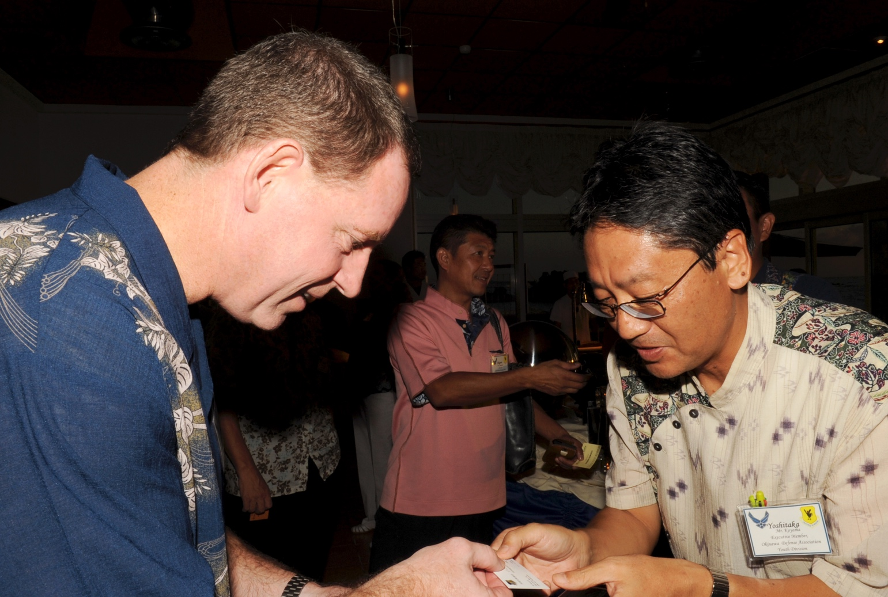
Principal learning objectives for this chapter
Successful interaction with this and associated course content will enable students to…
- Compare and contrast environments' effects on speech
- Discuss issues of space and time orientation in different contexts
- Discuss the intercultural context of business/professions

Topics covered in this chapter…
I. Environmental contexts
- The impact of the environment on conversations
- Built environments and communication patterns
- Privacy across cultures
- Cultural spaces
- Car and driving behavior in a cultural context
- Time orientation
II. Professional and institutional contexts
- Business and organizational contexts
- Equity and ethics
- The importance of names
- Communicative genres
- Translation and interpretation
- Education
TECHNICALLY SPEAKING: Professional discourse & privacy online

Wal-Mart is the largest and most successful retailer in the world. It offers low prices through economies of scale, an efficient purchasing and delivery system, and low employee wages. Its home base is in the US, but it operates in countries across the globe. In many of those markets, Wal-Mart has been successful, for example in Great Britain and South America. However, Wal-Mart has been less successful in Japan, Korea, and India. Given the location of those markets, one might be tempted to assign Wal-Mart's lack of success to differences in Asian cultures and in consumer preferences. However, Wal-Mart has been largely successful in China. Moreover, it has not been universally successful in cultures closer to that of the US. Germany provides the clearest example.
A closed Wal-mart store in Germany
There are many differences between Germany and the US, but they share a number of cultural traits including a strong work ethic, a generally individualistic orientation, a fundamentally egalitarian social and political structure, a monochronic time orientation, and a shared linguistic family (Germanic language group within the Indo-European family). However, it was in fact largely cultural issues that led to Wal-Mart's failure in the German market. The stores in Germany were run very much like those in the US, and that was the cause of many of the problems that arose. Here are the most important cultural factors:
Consumers. Wal-Mart stores had smiling "greeters" at their entrances. The company instructed cashiers to smile at customers. Germans do not tend to smile at strangers. German consumers found the personal greetings of the smiling greeters offensive – this kind of informal chatting with strangers is not the norm in Germany. The smiles from the cashiers were interpreted as mocking or flirtatious.
Products. The product line did not match the cultural habits and preferences of German consumers. Meats, for example, were prepackaged; many Germans prefer to have meat cut on demand. Products were in some cases packaged in large quantities. Storage in refrigerators and cupboards in Germany is much more limited than in the US; German consumers tend to buy smaller quantities and shop more often. Local or regional products were not offered. To achieve economies of scale, Wal-Mart tends to carry the same products across all stores. Germans often identify closely with their home region, which often will include specific food and beverage preferences (sausage or beer, for example). German consumers are used to putting purchased items into bags they themselves have brought to the store, and they found Wal-Mart's practice of bagging products for consumers into plastic bags unfamiliar and undesirable.
Employees. It's common practice at Wal-Mart's in the US to have employees engage in group chants before the store opens, designed to build store morale and company loyalty. This practice is not common in Germany, and was perceived negatively by Wal-Mart employees. Because of regional differences and family relationships, most Germans prefer to remain near the area in which they grew up. Wal-Mart expected employees – especially managers – to be willing to relocate based on company needs. In the US, it's not uncommon for someone to seek employment far from one's home base; that's less likely in Germany. The anti-union policy of Wal-Mart also ran up against the German tradition of strong trade unions. It's also the norm in German companies that there be institutionalized employee input into company decision-making. That was not the case at Wal-Mart Germany.
Culture loams large in international business; companies ignore cultural issues at their peril. The example of Wal-Mart in Germany demonstrates that a reliable model in one culture does not necessarily work world-wide. In this chapter we will be looking at issues which arise in intercultural communication in particular environmental and professional contexts. This will include some discussion of issues related to physical space, such as privacy and time orientation. Also discussed will be the role of translation/interpretation. We conclude the chapter with an examination of cross-cultural issues in education and an excursion into driving and car culture across cultures.

The impact of the environment on conversations
The nature of conversations is determined by the conversation partner, the purpose of the encounter, and the context in which it occurs. Germans who went to Wal-Mart were there to buy goods, not to engage in conversations with strangers. Those same Germans may have a quite different attitude towards talking with strangers if they happen to be sitting at the same table with tourists at a local beer garden. How they talk with those tourists will be quite different than a conversation over a beer with friends or co-workers. Where a conversation takes place can have a significant effect in terms of language used. In a beer garden, one may have to speak louder than normal and, because of the mixed clientele, be prepared to speak using a simplified version of one's native tongue or English. The language used will likely be quite different from that at the workplace, more informal, with quite different subjects discussed.
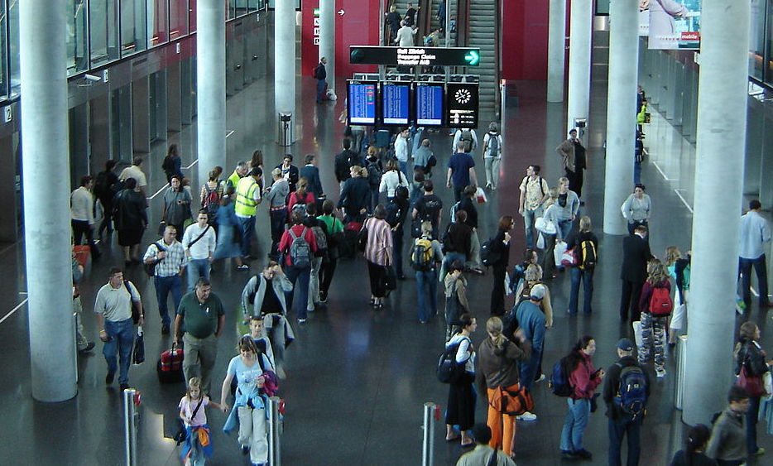
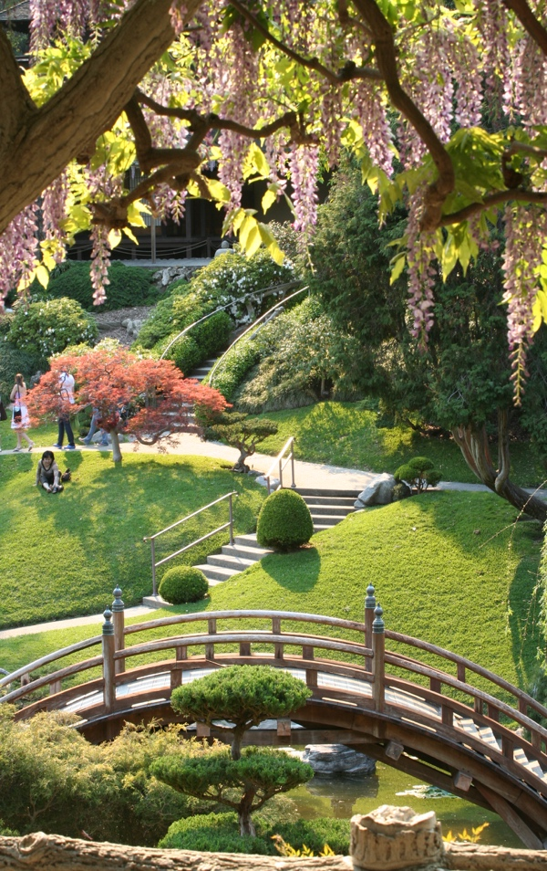
Quiet, isolated environments are likely to lead to different conversation dynamics than a crowded, noisy environment. Environmental psychologist Albert Mehrabian devised a theory in which he emphasizes the varying information rates in different environments (1977). Information rate is the amount of information contained or perceived per a certain unit of time; the more information available to process, the greater the information rate. An environment with a high information rate is said to have a high load. Examples would be a busy airport or popular restaurant at lunch time. Environments with a low load might be a library reading room or a Japanese garden. According to Mehrabian, the higher the information load, the higher the anxiety, leading to discomfort and possibly anxiety. Those feelings are exacerbated by the presence of people we don't know, particularly if they are from a different culture. It's likely that most people would avoid whenever possible high load situations. From that perspective, encounters with strangers work best if carefully managed, with small numbers of conversants in a quiet setting.
Crowded airport in Zurich, with a high load
Japanese garden, with a low load
Some cultures purposely create spaces with low information loads for particular purposes or cultural practices. Japanese gardens are intended to facilitate silent contemplation and meditation (Itoh, 1981). They feature carefully designed landscapes with flowing streams, rock formations, meandering walkways, and well-placed benches or other seating. The impression is one of informal natural beauty. In reality, everything in a Japanese garden is carefully planned out to create impressive views and perspectives. In contrast, the US "backyard" is a setting for socialization and sport. Typically, there will be an extensive lawn, well-maintained, allowing room for outdoor activities. This might be used for informal social gatherings, featuring meats cooked on the grill. The overall impression of an American backyard is of an environment created by man, while that of a Japanese garden is a harmonious blend of natural elements. There will clearly be a different dynamic at work in conversations held in an American backyard compared to a Japanese garden. In fact, a Japanese garden is more an invitation to silence (highly valued in that culture) than to conversation. The different spaces also point to contrasting views of the relationship between man and nature. Western culture tends to want to change and dominate nature. Asian cultures look to harmonize with nature.
A US backyard featuring games & socializing

Built environments and communication patterns

The design of built environments, such as private homes or office buildings also has a significant effect on communication. The traditional design of Japanese homes points to particular cultural norms and values, as well as typical communication patterns and practices in Japan. Because the Japanese believe in harmony with nature, traditionally Japanese homes are unobtrusively integrated into the landscape. The most important room, the sitting room, typically opens up onto the garden, with wide doors which can be opened to eliminate the barrier between house and garden. Often the garden offers its best views from the multiple open spaces along the outside of the house. One has the impression that the garden and the house flow into one another. The sitting room of a traditional Japanese family home is typically large and can be subdivided using semi-transparent screens called shoji. This allows considerable versatility, with divisions of the rooms easily changed. This modularity carries over to the traditional flooring of Japanese homes. Straw mats called tatami are used for sitting or sleeping. The flexibility in arranging living quarters accommodates the easy sub-division of space to allow for additional members of an extended family. It also enables creation of semi-private space as needed. In that way, it satisfies the need for social space for conversation as well as the possibility of withdrawal into silence and contemplation. Japanese society has changed significantly in recent decades, becoming less homogeneous and less traditional, under Westernizing influences. That has affected housing styles as well. Research has indicated however that the majority of Japanese still favor a traditional style (Ueda, 1998), with elements of traditional design typically incorporated into modern homes and office space whenever possible.
Tall hedge surrounding house in Höfen, Germany
Japanese house in harmony with the surrounding garden
In contrast to the semi-fixed featured space of traditional Japanese homes, houses in Germany tend to favor fixed-featured space in which room divisions are permanent. These distinctions and terms were made by Edward Hall (1966) initially and are often used in descriptions of built environments. Germans tend to divide up space according to its function and to find and maintain an ordered space for all household objects and possessions. Important is that there be clear divisions, with the ability to close doors to all rooms, secure windows with heavy shutters, and surround the garden with tall hedges, fences, or walls. The house design reflects cultural aspects of life in Germany. There tends to be a strong sense of orderliness in German society (reflecting the German saying Ordnung muss sein – order is a must), with a strict adherence to rules. In accordance with that respect for order, Germans expect commitments and promises to be kept. That includes agreements regarding appointments and meet-ups; Germans are punctual and expect others to be as well. That sense of order carries over to personal interactions. Germans seek clarity in relations with others, which is reflected in the careful differentiation of people with whom one uses a formal level of address (the formal you Sie) from those with whom one is informal (du form). In contrast to other cultures which also have formal and informal modes of address (French, Spanish), Germans tend to be more rigid and systematic in their use of those forms. It's not unusual for Germans to maintain the Sie form even with close work colleagues. The desire for clarity tends to lead Germans to use a very direct style of communication, with the reputation of being sometimes overly blunt, leading to charges of insensitivity.
Greg Nees, in his cultural study of Germans (2000), draws a connection between the cultural theme of order and the design of space (see sidebar). These two examples illustrate the connection between environments and communication, but they by no means exhaust the options for living environments to be found in human cultures. Another option discussed by Hall is informal space, with no permanent divisions or walls. Informal space plays a major role in the everyday living experiences of people in Africa, parts of the Middle East, and rural areas world-wide, where outdoor space and non-permanent housing becomes an integral and vital aspect of work and family life. Living in a tent or in a communal space clearly can have a major impact on communication.
Close that door! You're in Germany
The mutual influences of clarity and order reinforce one another and help create a strong tendency toward compartmentalization in all areas of their lives, for example, inside their dwellings. The open architecture typical of American houses and apartments in which the front door opens into the living room is not common. Walk into a traditional German home or apartment and you will usually find yourself in a small, closed corridor, or Gang. This corridor provides access to the other rooms of the house or apartment, and the doors to these other rooms will generally be closed. This configuration is considered orderly...Doors remain closed in most German public and office buildings, where a closed door does not mean a private meeting is taking place, but only that the door is closed as German notions of orderliness and clear boundaries dictate (p. 48).

Privacy across cultures
Although human beings are by nature social animals, we all also need time alone. The degree to which people seek and value solitude varies across cultures, as does the means and mechanisms for being alone. Knowing about norms and conventions regarding privacy can be important in encounters with others. The extent to which one's home is considered a private sphere, for example, can vary. In the US, guests invited over for a dinner party are likely to be given a "house tour" and be shown even intimate space such as a master bedroom. Guests will often congregate in the kitchen to converse while the host or hostess is preparing the meal. They are likely to be invited to help themselves to a drink from the family's refrigerator. The dinner party is likely to play out quite differently in other cultures. In the two environments discussed above, in Japan and Germany, guests are likely to see only the main rooms for guest entertaining. They will likely not be invited to roam freely throughout the house, or to use space designed for family use (except for the toilet). Guests are unlikely to socialize in the kitchen, which in both countries is a smaller space than is typical in the US. In both countries, that space is intended for the dedicated use of food preparation, traditionally the domain of the housewife. The kitchen is not viewed in any case as an appropriate location for extended conversation. The informality of communication patterns in the US allows for great flexibility in where casual conversations can take place. In other cultures, more formal rules of etiquette and social interactions will limit the range of options. In Germany in particular, social space and interactions are carefully compartmentalized, with clear distinctions and divisions in place. Separating off one's garden with a hedge or fence, for example, signals that the space is reserved for family use.
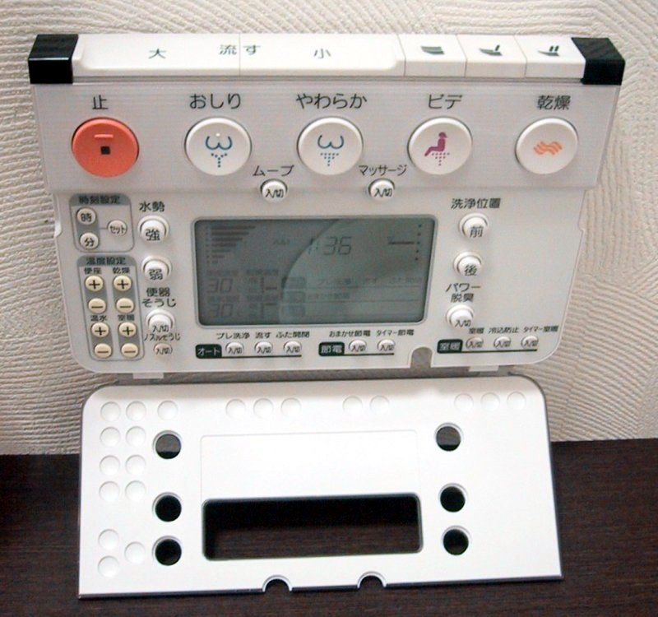
Germany and Japan are densely populated countries in which privacy is particularly valued. There are different ways to achieve that privacy. Architectural scholar Jon Lang (1987) identified four types of privacy: a) solitude, in which one is free from observation by others; b) intimacy, or shared privacy; c) anonymity, going unnoticed by others especially in a crowd; and d) reserve, in which one uses psychological means to create imagined isolation. Living in Tokyo (or other large metropolitan areas), office workers on the morning commute are likely to seek "anonymity" in crowded buses or subway cars. Once at the office, they may use "reserve", the only means of achieving privacy in a cubicled office environment. Once back home, the office worker might seek "solitude" in a specifically Japanese cultural way, by retreating into the bathroom. In Japanese houses, the bathroom is separated from the toilet and typically consists of two distinct areas, one for bathing (using a shower and soap) and one for soaking (the tub). The space is kept absolutely clean and made as attractive as possible, with the soaking water often scented with flowers or lemons. It can be a place for private relaxation and meditation.
Wireless toilet control panel in Japan
The toilet offers the worker another opportunity for privacy, a valued commodity in a culture that places high value on social harmony, consensus building, and teamwork, all activities calling for contact with others. The toilet itself points to another key aspect of contemporary Japanese culture, the fascination with gadgets and electronics. Many Japanese toilets are high-tech, with a sophisticated control panel allowing for seat warming, massaging, and cleansing sprays. It may also play sounds and music. Soft music may help in relaxation and contemplation, while louder sounds may mask from others the personal activity occurring. That latter feature demonstrates that even in the search for privacy, Japanese tend to take into consideration those around them. Privacy in such a culture is fleeting, and therefore is all the more sought and cherished.
Notions of privacy are related to the sense of private ownership, which can also differ markedly across cultures. In the US, with a strong tradition of individualism and private ownership rights, mainstream cultural norms include sharp divisions between one's own possessions and those of others, including in a family environment. In other cultures, there are traditions of sharing and communal ownership, such as in Native American co-cultures. John Baldwin, a US scholar of intercultural communication recounts his personal experiences of privacy and attitudes towards personal possessions while living in Brazil (see sidebar). Brazil has a great variety of living spaces, with immense differences between life in the Amazonian rain forest and in major metropolitan areas like Rio de Janeiro or São Paulo. One of the indigenous tribes are the Mehinaku Indians. They live in communal villages with no privacy. Their huts house families of ten or twelve people. They have no windows or internal walls, and have doors that open unto an open area that is in constant view. The family members sleep in hammocks, suspended from a common house pole. According to anthropologist, Thomas Gregor (1980), "Each individual's whereabouts and activities are generally known to his relatives and often to the community as a whole. A Mehinaku has little chance of staying out of the public eye for any length of time" (p. 67). To be alone, villagers have only one option, to leave the village.
Naked? "This is Brazil. No one cares"
When I lived in Brazil, I was on the Amazon river...The environment clearly interacted with everyday life. Daily temperatures were usually in the 90s and 100s F. [35-40 C.], with a very high humidity. When you show up at someone’s home, they offer you a shower instead of a drink. You take off your clothes, hop in the shower to cool down (but never after eating, because faz mal [“it harms you”]), then put on the same clothes. One time, I went to the shared shower-shed between the houses in the housing area (a wooden shed with a garden hose hanging down). There was a wood plank missing. I went back and asked my host, “What do you wear to shower here?” He laughed and said, “Nothing, of course!” “But there’s a board missing,” I said. “John,” he replied—“this is Brazil. No one cares.” This leads to the notion that, because of climate and social factors, the notion of modesty was also quite different...Many of my friends thought nothing of using my cologne, my toothpaste., even my toothbrush...Because of crowdedness, especially among the working classes, privacy is conceptualized differently. If I stayed at a friend’s house, I would expect to bring my own hammock and string it across the living room—often with other family members
Baldwin, 2008

Xavante villagers in Brazil

Cultural spaces
There is clearly a connection between the spaces humans inhabit and the cultural practices which take place there. Living in an Amazonian village will dictate behaviors and communication patterns quite different from those in an urban environment such as Paris. Donald Carbaugh (1999) describes the practice of "listening" (silent contemplation and meditation) of the Native American Blackfeet tribe in sacred locations or inspired by certain sky conditions or landscapes. The practice illustrates the Indian sense of connectedness of humans and all of life with nature. Non-Indians are not likely to have the equivalent experiences in the same physical setting (see sidebar). Thus, individuals and groups may experience the same physical space very differently. Paris, for tourists, is a place of wonder and discovery. For inhabitants of the Parisian suburbs (banlieux in French), where many Muslim immigrants live in crime-ridden high-rise apartment buildings, Paris might have a very different meaning, suggesting a life of poverty and hopelessness. For business people, Paris represents a center of commerce and economic opportunity. In recent years, Paris has served as a place for terrorists to engage in brutal attacks for maximum visibility.
Don't eat lunch there – it's sacred
Recent discourse and culture studies have reminded us how intimately cultural worlds and discursive practices indeed are… Without knowing the place, we are unsure how to act. Discourses of place thus suggest cultural actions, yet any one place might suggest multiple cultural discourses. We may think we know something, through a discourse, get this knowing may be somewhat out of its cultural place, as when one ascends a small hill for lunch, only to find later that one's lunch site is a secret burial mound. In retrospect, we find our habitual action and cultural knowledge are somehow out of place.
Carbaugh, 1999, p.251

The example of Paris reminds us of the complexity of modern urban spaces. Villages and rural spaces tend to be monocultural, an environment in which strangers are infrequently encountered and can be ignored (see Rogers & Steinfatt, 1998). With the advent of the industrial age, beginning in 18th century England, there's been a major demographic shift in many countries, as rural inhabitants move to cities to find employment and more opportunities for themselves and their families. In the process, cities have absorbed groups representing a variety of cultural backgrounds. In the US in the late 19th and early 20th centuries, ethnic or racial neighborhoods were created with inhabitants living largely separated from mainstream communities. These neighborhoods and ghettos were often created through segregation, not through the wishes of the group members. In San Francisco, for example, racial politics isolated Chinese immigrants within Chinatown:
The sense of being physically sealed within the boundaries of Chinatown was impressed on the few immigrants coming into the settlement by frequent stonings which occurred as they came up Washington or Clay Street from the piers. It was perpetuated by attacks of white toughs in the adjacent North Beach area and down- town around Union Square, who amused themselves by beating Chinese who came into these areas (Nee & Nee, 1974, p. 60).
Patterns of discrimination and separation have persisted in the US, with African-Americans, Hispanics, and other cocultures concentrated in particular neighborhoods. That process occurs worldwide. In Europe, Turkish communities occupy particular districts in German cities, as do North Africans in French cities. This dynamic can vary with the particular ethnic group and city.
Martin and Nakayama (2010) discuss the concept of "postmodern cultural spaces" in which city neighborhoods and boundaries in many places are becoming more flexible and fluid (see sidebar). This kind of fluidity stands in contrast to the traditional notions of fixed space and time, just as online communities today, too, challenge notions of fixed terrestrial and temporal boundaries. In the process, identities have become more complex, as we navigate discourses in different locations and contexts, both physical and virtual.
Polish-Americans today in Phoenix, Arizona
The ideology of fixed spaces and categories is currently being challenged by postmodernist notions of space and location. Phoenix, for example, which became a city relatively recently, has no Chinatown, or Japantown, or Koreatown, no Irish district, or Polish neighborhood, or Italian area. Instead, people of Polish descent, for example, might live anywhere in the metropolitan area but congregate for special occasions or for specific reasons. On Sundays, the Polish Catholic Mass draws many people from throughout Phoenix. When people want to buy Polish breads and pastries, they can go to the Polish bakery and also speak Polish there. Ethnic identity is only one of several identities that these people negotiate. When they desire recognition and interaction based on their Polish heritage, they can meet that wish. When they seek other forms of identification, they can go to placs where they can be Phoenix Suns fans, or community volunteers, and so on. Ethnic identity is neither the sole factor nor necessarily the most important one at all times in their lives.
Martin and Nakayama (2010), p. 296

The cultural space we experience growing up typically has a marked influence on our personal identities. We all start somewhere and the local and regional characteristics of that locale imprint on us in profound ways. The regional accent or dialect will likely stay with us, even if just as a family or emotional linguistic resource. I never knew a colleague of mine was from Long Island, New York, until I heard him talk to members of his family, when the neutral US East Coast English yielded to a strong Long Island accent. That accent reappeared later when I overheard him in an angry conversation in his office. Our tastes in food and drink may be shaped by our initial home base, as are other values, habits, and preferences. The house or apartment in which we live initially is likely to leave cultural resonances which relate to privacy, orderliness, cleanliness, and personal space orientation. Many of these values relate to socio-economic class – how neatly we want (or can afford to) maintain the house/furniture/garden/car.
The initial cultural space makes a mark but does not define us – as we grow we encounter overlapping cultural spaces which provide different perspectives and subject positions. This will affect the language we use:
A cultural space is not simply a particular location that has culturally constructed meanings. It can also be a metaphorical place from which we communicate. We can speak from a number of social locations, marked on the 'map of society,' that give added meaning to our communication. Thus, we may speak as parents, children, colleagues, siblings, customers, Nebraskans, and a myriad of other 'places.' All of these are cultural spaces (Martin and Nakayama, 2010, p. 287).
Today, the cyberspaces we visit or inhabit provide still another layer of space and discourse.

Car and driving behavior in a cultural context
When we talk about human living spaces today, one of those difficult to ignore is the automobile. Most of us spend large blocks of time driving or riding in the car. Anyone who has done much traveling outside one's home country has likely been struck by the difference in car cultures, driving behaviors, and traffic patterns. In the US and the UK, for example, drivers generally follow traffic rules and drive in an orderly and predictable way. In other countries, such as Nigeria, traffic regulations are largely ignored. In that country, as well as in others in Africa, cars must compete for space on the road with vehicles of all kinds in addition to pedestrians and street hawkers. In India, cows roam freely over roads, including on the Indian equivalent of major, divided highways.
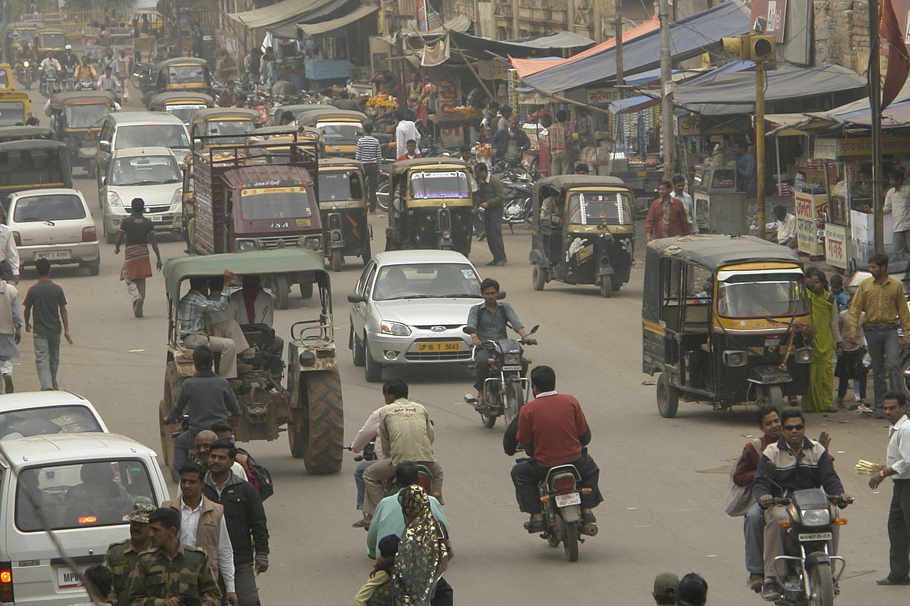
As is the case in schools and businesses, driving behaviors often reflect aspects of national cultures. North American and German drivers, for example, will assume that they have the freedom and the individual right to claim the right-of-way if traffic rules allot it to them. They are likely to be upset if others do not respect that right and go out of turn or cut them off. The pattern of driving behavior in cultures deemed collectivistic is quite different. In China and India, for example, drivers behave in a very different fashion, allowing others to merge or turn, even if that goes counter to the right of way or to traffic regulations. For those used to Western patterns of driving, the seemly chaotic flow and merge of traffic in India may seem inexplicable and dangerous. Yet in India, it is a functional chaos which actually does have informal rules of order. Precedence is given by size of vehicle, with pedestrians yielding to bikes and carts, bikes and carts to cars, cars to buses, and buses to trucks.
Road traffic in India: functional chaos
It's not just how we drive that may be different, but as well what it is we use our cars for. Europeans in general see cars as a dedicated means of transportation and when driving focus exclusively on that activity, with the goal of getting from A to B as quickly as possible. US Americans, on the other hand, see their cars as extensions of their personal living space and as an appropriate location in which to carry out all kinds of everyday activities, from eating/drinking to dating. In the US, drive-throughs are available for all kinds of activities, from picking up medications at a pharmacy to getting married (in Las Vegas). Edward Hall commented in Hidden Dimensions (1966) on the size of American automobiles, contrasting it with French cars:
The French automobile is designed in response to French needs. Its small size used to be attributed to a lower standard of living and higher costs of materials; and while there can be no doubt but that cost is a factor, it would be naive to assume that it was the major factor. The automobile is just as much an expression of the culture as is the language and, therefore, has its characteristic niche in the cultural biotope. Changes in the car will reflect and be reflected in changes elsewhere. If the French drove American cars, they would be forced to give up many ways of dealing with space which they hold quite dear. The traffic along the Champs-Elysées and around the Arc de Triomphe is a cross between the New Jersey Turnpike on a sunny Sunday afternoon and the Indianapolis Speedway. With American-size autos, it would be mass suicide (p. 145).
Today, globalization has affected the automobile industry, as it has all others. The same kind of cars are sold and driven all over the world, and their national prominence is difficult to determine, as parts typically come from suppliers in multiple countries, with manufacturing plants also spread worldwide.

Time orientation
Cultures use and divide up space in different ways. This is true of time as well. The different perceptions of time, such as the importance of punctuality, can be a source of friction in intercultural encounters. Edward Hall (1959) distinguished between monochronic and polychronic orientations to time. In the former, time is carefully regulated and highly compartmentalized, with schedules and punctuality being stressed. So-called "M-time" (monochronic) oriented individuals prefer to perform one activity at a time and prioritize keeping to a schedule. Tardiness and missed appointments are a source of anxiety. Time is seen as a limited commodity. The needs of people are subservient to the demands of time. Plans are not easily changed. People live by an external clock.
Those growing up in a culture with a monochronic time orientation are likely to see this view of time as natural and universal. In fact, it is culturally determined and learned. In such cultures, like the US or Germany, children are taught early, at home and in school, the importance of time, scheduling, and promptness. In polychronic time oriented cultures, however, the attitudes towards time are very different. Representative cultures include southern Europe, Latin America, Africa, and the Middle East. Schedules are less important, and punctuality is not considered an essential virtue. "P-timers" are used to having more than one activity or conversation going on at the same time. Individuals are more tolerant of interruptions and going beyond scheduled time. Time is bent to meet the needs of people, with the attitude that there is always more time. Consequently, plans are fluid. People live by an internal clock. Greater importance is placed on the natural progress of conversations than in keeping to a pre-arranged schedule. Life is lived in the moment, not in relation to a schedule. Because multiple activities and conversations going on simultaneously is an accepted part of P-time culture, space is often designed accordingly, with large common spaces. In M-time cultures, it's more likely that office or government buildings will be constructed with individual private offices. In those smaller spaces, more restricted conversations are likely.

Business and organizational contexts
Different perceptions of time, in particular scheduling and punctuality, can be important factors in international business. Differences in time perception can also affect negotiations of agreements or contracts. Business people from M-time cultures are likely to have pre-determined deadlines, either fixed mentally or in writing. This may be problematic if dealing with a P-time culture in which negotiations are seen as taking whatever time is needed for completion. There are likely to be significant differences among business cultures in the framework for negotiating or building business relationships. In low-context cultures, like northern Europe, the businesses are likely to have a preference for beginning substantive conversations immediately. In other cultures, especially in high-context cultures, such as China, the Middle East, or Latin America, there may be a desire to establish first a personal relationship between the parties involved, before beginning serious business conversations. This might involve informal "small talk" unconnected to business or getting together socially, for a meal or drinks. Only after confidence in the other party, along with a certain degree of familiarity, are established will a business relationship be possible.
In general, business and other professional cultures mirror the values and behaviors of the mainstream culture of the country. In high power distance cultures, hierarchies are expected and accepted, with clear divisions and privileges accorded to individuals depending on their social rank, status, or background. This will typically be reflected in the business culture, which will be status conscious with top-down communications and decision-making. In contrast, in small power distance cultures, like the US, there's likely to be a more participatory style of management, with employees being asked their opinion on work-related issues. Communication styles used in business transactions mirror as well predominate patterns in the culture at large. Business people from India and the US, for example, are likely to use quite different verbal styles. The US representatives are likely to be direct, addressing issues forthrightly. If there is a problem or contentious issue, the Americans will expect an open and detailed discussion. Indians might well be more circumspect, preferring an indirect style in which disagreements are glossed over or postponed for discussion at a later time.
Within businesses or other organizations there is likely to be a system of shared values which determine how people behave within the organization. This "organizational culture" reflects the culture at large, but at the same time may vary depending on the type and size of the organization, the location of its home-office, and the type of activity business in which they engage. The organizational culture of a small NGO (non-governmental organization) will likely be quite different from that of a large multinational company. Trompenaars and Hampden-Turner (1997) developed a framework for characterizing organizational cultures, based on a large-scale survey involving employees from 43 countries. The model of cultural differences they developed has five dimensions for how people interact, plus one dealing with time (sequential versus synchronic) and one dealing with the environment (interior versus exterior control):

Individualism versus communitarianism
Generally, communitarian organizations make decisions through group consensus, with more attention paid to teamwork and social cohesiveness. Organizations from individualistic cultures, on the other hand seek out and reward individual performance and high achievers.

Universalism versus particularism
Universalists deploy the same ideas and practices everywhere, while particularists adjust to context and circumstances. Organizational cultures with high particularism such as China place a greater emphasis on developing relationships.

Neutral versus emotional
Neutral cultures hold emotions in check (in Japan, for example), while high emotion cultures (Mexico, Israel) expect emotions to be displayed openly and fully, including in business contexts.

Specific versus diffuse
"Herr Professor Doktor Schmidt" or "Bob"?
An example of these specific and diffuse cultural dimensions is provided by the United States and Germany. A U.S. professor, such as Robert Smith, PhD, generally would be called “Doctor Smith” by students when at his U.S. university. When shopping, however, he might be referred to by the store clerk as “Bob,” and he might even ask the clerk’s advice regarding some of his intended purchases. When golfing, Bob might just be one of the guys, even to a golf partner who happens to be a graduate student in his department. The reason for these changes in status is that, with the specific U.S. cultural values, people have large public spaces and often conduct themselves differently depending on their public role. At the same time, however, Bob has private space that is off-limits to the students who must call him “Doctor Smith” in class. In high-diffuse cultures, on the other hand, a person’s public life and private life often are similar. Therefore, in Germany, Herr Professor Doktor Schmidt would be referred to that way at the university, local market, and bowling alley—and even his wife might address him formally in public.
Luthans & Doh (2012), pp. 126–127

This dimension deals with the question of whether organizational roles and titles continue to play out on the outside (high-diffuse cultures) or whether individuals are treated differently in public and private spheres (specific cultures). See the sidebar for an example.

Achievement versus ascription
In ascription cultures, respect and success may be accorded based on birth or kinship, while in achievement cultures, the basis for judgment is hard work and individual success.

As always with such broad categories, these too need to be viewed as patterns, not absolutes. Organizations may well embrace different values from the surrounding cultures for a variety of reasons, such as marketing (counter-cultural hipness), the personal views of the owners (fundamentalist Christian values) or due to the size or diversity of the organizational members. The effects of globalization have had a varied impact on organizational cultures. In some instances national or regional organizational cultures have converged with Anglo-American practices, while in other cases forces of nationalism and independence (patriotism, historical traditions, economic self-sufficiency, political considerations) result in a rejection of imported organizational ideas and practices.

Equity and ethics
An area where divergence is evident is in the role and treatment of women in professional settings. Some cultures, maintain the traditional roles of women as housewives and mothers, with women working predominantly in "nurturing" professions such as healthcare and education. Worldwide, women are underrepresented in leadership and management roles in both the business and political arenas. In some countries, this is recognized as a major problem, given the injustice of the situation and the practical result of eliminating half the population from consideration for playing important societal roles. Entrenched centers of power ("old boys networks") tend to perpetuate the status quo. In some European countries, this has led to legislation which institutes quotas for women in positions of authority, such as members of the legislature or on corporate governing boards.
Women in leadership roles is rarely seen in many cultures
Some issues of equality and ethical behavior in professional interactions may be settled by law. Many more, however, are not legislated, but are the products of custom and tradition, and are regulated informally within communities. One practice which differs across cultures is gift giving in business settings. In many cultures, it is an accepted and expected behavior to offer or exchange gifts. This may be a token gift of little monetary value, such as a branded or traditional item or culinary specialty from one's home country or region. Difficulties might arise if items have unintended cultural values in the other's home culture, such as a symbolic value attached to a color, number, item of clothing, or food. Certain items may run counter to cultural taboos — a bottle of wine, for example, or a food item containing pork or beef. Including gifts for family members may be seen as a friendly attempt at building a relationship, but could run into difficulty if cultural norms see family members as a private sphere, not to be brought in to interactions with strangers.
Potentially more problematic are situations in which expectations go beyond simple gift giving to receiving bribes. In some parts of the world, giving and receiving bribes is a normal part of conducting business, as it is a fact of everyday life for inhabitants of that country. Foreign business people may run into difficulties in this area for a number of reasons. They may be personally and ethically opposed to bribery, seeing it as a form of corruption that rewards those already privileged in the society. Even if they want to pay, it may be difficult to negotiate a reasonable amount if one is not conversant with the local norms and practices. Payment of bribes may also not be permitted by company policy or may be forbidden by law. US business people, for example, must observe the Foreign Corrupt Practices Act of 1977.
On the other hand, large, powerful multinational corporation's may not act fairly when conducting business in foreign countries. US companies have been especially guilty of exploiting workers and resources in developing economies. While especially egregious cases occurred in the 19th and 20th centuries by fruit companies doing business in Latin America, today Western companies continue to exploit workers in garment, electronics, and other industries. The US government itself has been guilty of fostering projects that enrich the wealthy rather than helping the poor. Rogers and Steinfatt (1999) catalog how many USID projects of the 20th century fit that pattern. In fact, the recognition of the need for greater cross-cultural understanding on the part of employees of the US Department of State. Sustainable development projects can only be successful if they take into account local cultural values and social structures.

The importance of names
An important issue in establishing good relations cross-culturally is to use appropriate forms of address. This is as prominent an issue in business and professional settings as it is in personal relationships. In the US, informality guides modes of address. In university settings, sometimes students are invited to address their professors using first names. In business, it is not uncommon for subordinates to be on a first name basis with their bosses. In setting up new business relationships, US business people are likely to prefer moving to a first name basis as quickly as possible. That may be considered inappropriate and discourteous in other cultures. There may be an expectation not only to use a more formal mode of address, but also to include titles or honorifics, as appropriate. Mexicans, for example, make heavy use of honorific titles to show respect. New acquaintances met at a party are addressed as señor, señora, and señorita. In business, people address managers with titles like director, doctor, ingeniero (engineer), or licienciado (someone who has a higher education degree).
Pronouncing the counterpart's name correctly can be important as well. That might prove problematic depending on ones knowledge of the language involved. That's likely to be the case for honorifics as well, especially in cultures such as Korea. Getting the name right might be difficult in countries like Russia, where names are grammatically inflected, along with all nouns, and where patronymics are widely used. The knowledge of the language of one's business partner can of course be crucially important, depending on the linguistic ability of the partner, as well as the availability of a lingua franca such as English.
How one addresses counterparts and, in fact, how the relationship develops may relate to both the formality of a given culture and the degree of importance of social hierarchies, i.e. the extent to which it is a high power distance culture. In cultures that subscribe to a hierarchical view of social status, status is normally ascribed by birth, appointment, or age. Differences in status are made obvious through protocols that govern many interpersonal and organizational activities. In a business setting, problematic relations can quickly develop if the participants adhere to conflicting views on egalitarianism and hierarchy. The behaviors and actions of representatives from hierarchical cultures are frequently dictated by culture-bound rules relating to status. Recognizing the possible differences in this area can be crucially important in establishing effective relationships.

Communicative genres
The particular context and environment in which human speech occurs may determine parameters of what is said and how it is expressed. For particular occasions in a given location there may be culturally specific expectations for the language used, as well as for other actions, such as dress, affects displays, or body language. Günthner (2007) lists a number of such communicative genres in a range of situations from complaints and prayers to business negotiations and university lectures. In some contexts, there are conventional pre-patterned forms of language and behavior expected, which guide interactants' expectations. Communicative genres are “historically and culturally specific conventions and ideals according to which speakers compose talk or texts and recipients interpret it“ (Günthner, 2007, p. 129). They operate as orientation frames which limit the kind of speech used, helping speaker and audience by defining expectations and limiting interpretive possibilities. There may be situations which call for a particular genre. Kotthoff (1991) gives the example of toasts in Caucasian Georgia which use a limited canon of topics: "peace, the guests, the parents, the dead, the children, friendship, love, the women whose beauty embellishes the table" (p. 251). Foreigners unaware of the limited canon could cause in embarrassment to themselves and to their hosts by venturing outside that canon.
Communicative genres are particularly salient in professional and institutional settings. Miller (1994) discusses business meetings from this perspective. For US business people, meetings are "thought to be the appropriate place in which to persuade people or try to change their minds" (p. 224). This is the venue for making business decisions and closing deals. Miller points out that this is quite different for what Japanese business people consider to be the purpose of meetings. For them consensus is reached before the actual meeting, through informal discussions, often taking place at bars or cafes. The meeting's purpose is to express formal acceptance of the results of the negotiations, decided on beforehand. Similarly, Li (1999) found that frustration between Chinese and Western European business people derived from different approaches to the genre of conducting business negotiations. For the Chinese, developing good interpersonal relationships was vital, while for the Europeans moving quickly and directly to negotiations was central. Not being aware of the different repertoires and expectations for a given communicative genre can generate misunderstandings or conflict.
Günthner (2007) points out that cultural differences in genre related knowledge can have particularly unfortunate consequences if they their occur in "gate-keeping" institutional settings, for example, in education, healthcare, or legal matters. Scollon and Scollon (1981) provide examples of courtroom interactions in Alaska in which jail sentences are considerably longer for Alaskan Natives that for Whites. In studying court testimony, the authors found that Native Alaskans failed — in contrast to white defendants — to speak of positive plans for the future. This, however, is an expected behavior in US courts, namely that defendants commit themselves to self-improvement and social betterment. Pillar (2017) found a similar situation in relation to aboriginals in Australia (see sidebar).
Aboriginals in court: An unfamiliar communicative genre
Non-Aboriginal Australians are not familiar with the pronunciations, lexical and grammatical choices, and discourse and pragmatic conventions of Aboriginal Australians and the latter are unfamiliar with the conventions obtaining in mainstream institutions such as the court...The state imposes Standard English and there is a widely shared language ideology that Standard English is the ‘natural’ way of expressing oneself before a court. Coupled with Aboriginal people’s frequent ignorance of Standard English, this language ideology means that Aboriginal people before the law are oftentimes effectively barred from giving evidence, from presenting their character in a clear and detailed way, and generally from engaging in court proceedings as a meaningful interaction.
Pillar (2017, p. 91)

Translation and interpretation
Issues of intercultural communication are likely to be raised in all professional contexts. In health care and legal environments, effective communication between parties can be of life or death importance. In both of these areas, translators and interpreters play major roles. Interpreters are concerned with spoken language, translators focus on the written word. While simultaneous interpreting (translated in tandem with the speaker) is used widely in international meetings or conferences, more common in work environments is sequential translation. This involves short translations after the speaker pauses. This is what is used most commonly in law courts and hospitals. In some healthcare contacts, as well as in other environments, chuchotage may be used, in which the interpreter whispers simultaneous translation to a single client.
An interpreter for chess player Garry Kasparov using chuchotage
Interpreters and translators typically translate into their mother tongue. Even so, the process is complex and difficult. One must not only remain faithful in terms of content, but is expected as well to invoke the same emotional response. This is difficult for interpreters who are asked to work impartially for two parties. The goal is to provide pragmatic equivalence in which the utterance is re-created with all the nuances of the source. This might involve departing substantially from the literal wording of the original. It necessitates on the part of the interpreter significant knowledge of how both languages are used in real conversations, i.e. a good command of language pragmatics.
There are ethical issues that arise in interpreting, namely to the extent that one functions as an advocate for a given client. Although impartiality is expected of court interpreters, the power, language, and culture divisions between a non-native client and the justice system make it difficult to work objectively, and not to offer clarifying or justifying insertions or asides. This might be all the more an issue with clients who are poor and illiterate, therefore unlikely to be able to express themselves effectively, even in their native language.
Another temptation for interpreters is to serve in the role of institutional gatekeepers. This is especially the case in health care, where the interpreter might use his/her own judgment in not passing on to the physician all the information supplied by the client, viewing some statements as irrelevant. Professional training is needed to be able to carry out roles in legal and health care interpreting effectively. Unfortunately, in many cases the scarcity of professional interpreters leads to the use of untrained native speakers.

Education
In many countries, schools have become more diverse in their student populations, resulting in the need for intercultural communication competence among teachers and staff. Like business establishments, educational facilities reflect the cultures in which they are located. Prejudices and discrimination all too frequently follow children into the classroom. Children soak up cultural values around them and that includes the negative stereotypes they might hear from family members or other adults. The same kind of potential conflicts which may arise from mixing different ethnic, racial, religious groups in the culture at large can occur in schools as well. Since prejudices are formed early in life, it is important to counteract hatred and hostility in school environments.
In multicultural classrooms, there is likely to be a mix of learning styles. Among educational theorists it's well-known that each student may have a preferred learning style, whether that be visual, auditory, or kinesthetic. Those learning styles may be culturally influenced. Particular characterizations are often associated with ethnic or national groups. Asian students, for example, are said to rely on rote memorization, exhibit passive behavior in the classroom, and be extrinsically motivated. Western learning, by contrast, tends to be learner-oriented, with an emphasis on the development of learner autonomy and on active, even assertive learning behaviors in the classroom. Often, these descriptions favor Western approaches to education and classroom behavior. Active learning is generally seen as preferable, with students pro-actively engaged in learning, through volunteering to answer questions or entering into dialogue with teacher and peers. Being quiet or reserved is seen as problematic (Hua, 2013). An additional dynamic in multicultural classrooms is the power differential between native and non-native speakers of the language of instruction. It is problematic to view generalizations about learning styles as applicable to every individual student. This results in students from minority/immigrant communities or non-native speakers being automatically relegated to an underachieving status and treated accordingly.
Multicultural school group in Paris
An example in which a perceived Western educational practice has become normative is Kaplan's description of rhetorical styles. His mapping of how different ethnic groups write essays looks like this:
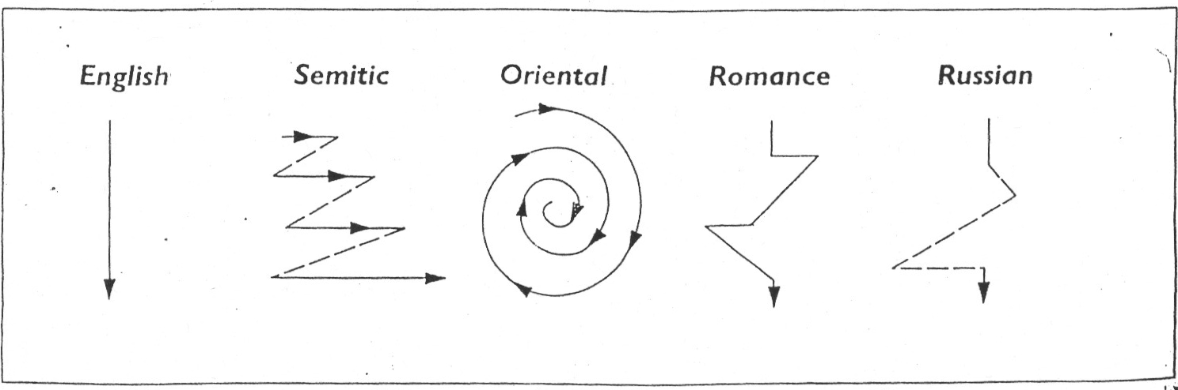
Kaplan (1966), p. 14
The Anglo-Saxon English approach is to get straight to the point, while Semitics zigzag, those from Romance and Russian languages go on tangents, and "Orientals" circle around the point. The characterizations are problematic for a variety of reasons, not just due to the inherent cultural caricatures. Kaplan draws his conclusions from essays written by ESL students in an academic setting, written in their second language. One analysis gives this summary:
[Kaplan's descriptions] implicitly reinforced an image of the superiority of English rhetoric and a deterministic view of second language (particularly English) learners as individuals who inevitably transfer rhetorical patterns of their L1 in L2 writing. Furthermore, the binary images of rhetoric constructed by the field, i.e., English is linear, direct, and logical whereas other languages are circular, digressive, or non-logical, parallel colonial dichotomies between the colonizer and the colonized (Pennycook, 1998), suggesting the hidden political or ideological nature of the conventional knowledge created by contrastive rhetoric (Kubota & Lehner, 2004, p. 9).
It happens seemingly inevitably that theories on cultural difference originating with Western scholars favor explicitly or implicitly Western approaches and behaviors.
One of the conflicts which may arise in multicultural classrooms comes from parents of immigrant or minority communities who have views of teaching and learning different from the mainstream culture and therefore in conflict with how instruction is configured in schools. In some cases, there may be excessive pressure from parents for the children to achieve academically, with expectations that students spend all their free time studying, so as to perform well on exams. That behavior in the US is often associated with Asian-American families. At the other extreme are parents from lower socioeconomic backgrounds who themselves had scant or negative school experiences and who don't convey to their children the importance of doing well in school. Remland et al. (2015) gives the example of a Cambodian-American family in which the parents view the teacher as parental substitutes and therefore find it inappropriate for themselves to play an active role in school affairs. She mentions the role as well that religion may play in such a case. As Khmer Buddhists, the Cambodian family likely sees fate as a guiding principle in human development, thus making it superfluous for children to exert undue efforts to better themselves through study. In such a situation, teachers need to gain the knowledge and sensitivity to understand the issues arising and shape communicative strategies with the family accordingly.

TECHNICALLY SPEAKING: Professional discourse and privacy online
The rapid rise of the Internet, with the new communication possibilities it enables, has wrought changes in how professional communication and business interactions occur. The ubiquitous availability of free or low-cost communication through the internet has in some areas leveled the playing field among competing businesses. It has also changed dramatically some branches of business and commerce. Physical music stores have gone out of business through the competition in price, selection, and convenience of digital music. A similar process is playing out with movies. Amazon has put many book stores out of business. The internet has also allowed all kinds of businesses to outsource their labor pool or their customer relations. The Internet changes not only how products and services are sold and provided, it also radically changes how companies communicate with their customers. The affordances of the Internet have led to the expectation of greater transparency on the part of companies. It also leads to the need for fast responses to developing situations. Bad reviews or negative news stories can spread rapidly, leading to the need for companies to keep tabs on social media and popular web sites, in order to have a rapid response to counteract bad publicity. Companies routinely have a presence on the web and in social media, in order to provide information, build customer relations, and provide a channel for their own take on reports and stories.
The important role that digital communications plays today in all branches of business and other professions has led to new job and advancement opportunities for those skilled in social media and online communication. It has also led to changes in the nature of business communication. Both internal and external communication is now done digitally. This change in communication mode has brought about a change in communication style. Communications on the internet tend to be more informal and unstructured than is the case with traditional business communications such as an exchange of letters. The dominant style on the internet is closer to the nature of oral rather than written communication. That style invites greater informality, along with a greater degree of freedom of expression. In some cultures, this might not signal a significant change, but it can mean a quite different dynamic in countries where communication tends to be more stylized and formal, with well-entrenched rules or traditions for personal and business interactions. Communication on the internet brings with it a sense of anonymity which tends to equalize social status. Junior executives may feel empowered through internet communications to bypass traditional approaches or barriers to communication with higher-ups. In some cases this could lead to a change not only in communication but also in corporate culture. In places like India the Internet may become a kind of equalizer since it is hard to assess a person’s status, rank, credibility, or caste membership online.
Just as the internet has made public much of what happens in corporations, it has done the same for individuals, namely making much of what happens in our lives knowable by anyone with internet access. This lack of privacy has become a serious issue in many parts of the world, in some countries more than in others. In has been a big concern in many European countries. There is an EU regulation that Europeans have the "right to be forgotten" on the Internet. This provides the opportunity for citizens to submit requests to operators of search engines (principally Google) to have items removed from searches. There is a similar regulation in Argentina. Many people are likely to have a lot of personal information show up in internet searches. That can come from a variety of sources, such as posts on social media, photos submitted to sharing sites, official transactions such as court proceedings or real estate transactions, reports on participation in clubs, sports or other free time activities, written assignments from school or university classes, etc. In some cases one would likely prefer to have some of that information not shared, especially in cases where we do not appear in the most flattering light. Employers are now often conducting a Google search on job applicants, so that internet rants or naked pics might prove problematic. It's good to be aware of the fact that your identity in today's world is increasingly being created by your online activities.

From theory to practice...
Here are some considerations in respect to communication in different environmental and professional contexts:

- Adjust your language and communication style to the environment in which you are located. In familiar settings, this is likely something you do automatically – speaking informally with friends over lunch, while using a more formal style in responding to a professor in the classroom. However, in unfamiliar settings, this may not come as easily. Heightened cultural sensitivity is especially needed in sites of significant cultural importance – places of worship, monuments. Speaking loud in a hallowed space, like the top of a holy mountain is inappropriate, as is snapping selfies of yourself naked.

- Beware of pragmatic transfer in speaking in formal settings. In most business and professional situations in many parts of the world, a more formal language register is expected. This means not only using formal modes of address and typical politeness formulas, but also watching out, if you are not speaking your native language, for keeping the formulation of "speech acts" (like greetings or leave-taking) in line with cultural norms. We often will instinctively translate word for word set phrases we use all the time, but that can sometimes cause miscommunication or awkwardness.

For discussion and reflection...

Time and speed in cultural contexts
After watching Honoré's "In praise of slowness" and Zimbardo's "Psychology of time"...
- What is your assessment of the concepts of time and speed presented in the videos? How does time effect your life (in terms of relationship building, work, school)? What do you make of the "slow" movement? Are you aware of schools or companies "slowing time" or enabling more free time? Comment on experiences you have had related to concepts/traditions of space and time across cultures

Alternative approaches to built spaces
After watching the videos on space and architecture by Kéré, Hardy, and Phillips...:
- Are we victims of "groupthink" and conformity in terms of housing design? How do you assess the importance of using traditional building materials? How does living in the communities discussed in the videos effect the way of life and cultural values and behaviors? How do you think the design of the 2 schools discussed, the "Green School" in Bali and the Gando school in Burkina Faso may effect learning experiences of students? What are your experiences, if any, with cultures having different kinds of living arrangements, housing, bathroom cultures?

International businesses
- Comment on experiences you have had related to international business, for example, different kinds of consumer practices, changes that US companies make in selling abroad (i.e., McDonalds, Wal-Mart)

Key terms

Built environment: Adaptations to the terrestrial environment, including architecture, housing, lighting, and landscaping
Chuchotage: Form of interpreting in which the interpreter stands or sits alongside a small target audience and whispers a simultaneous interpretation of what’s being said; the term chuchotage is French for whispering
Consecutive interpreting: Interpreters wait for the speaker to pause before interpreting; the interpreter may interpret after every sentence, or may take notes and then interpret several minutes of speech at once
Environmental context: The geographical and psychological location of communication within some cultural context
Fixed-feature space: Space bounded by immovable or permanent fixtures, such as walls
Gatekeeping: The process through which information is filtered for transmission or dissemination
Guanxi: Chinese for relationship or connection, refers to the importance of personalized networks of influence in the Chinese business community
High load: A situation with a high information rate
Informal space: Space defined by the movement of the interactants
Information rate: The amount of information contained or perceived in the physical environment per some unit of time
Low load: A situation with a low information rate
Monochronic time orientation: Cultural temporal orientation that stresses the compartmentalization and segmentation of measurable units of time
Monochronic time orientation: Time as linear, progressive, and being capable of being compartmentalized
Organizational culture: An organized pattern of values, beliefs, behaviors, and communication channels held by the members of an organization
Polychronic time orientation: Time as cyclical, people perform multiple tasks simultaneously
Pragmatic equivalence: Refers to words in two languages having the same effect on the reader/listener in both languages
Semifixed-feature space: Space bounded by movable objects, such as furniture
Simultaneous interpreting: Process which allows people to communicate directly across language and cultural boundaries using specialized technology and professional interpreters who are trained to listen to one language while speaking simultaneously in another
Taiso: Tai (body) + so (hardening) is a generic Japanese term for conditioning or exercising, a regular part of the daily routine in many Japanese factories

Resources

Space and housing across cultures
- Diébédo Francis Kéré: How to build with clay... and community
TED description: "Diébédo Francis Kéré knew exactly what he wanted to do when he got his degree in architecture… He wanted to go home to Gando in Burkina Faso, to help his neighbors reap the benefit of his education. In this charming talk, Kéré shows off some of the beautiful structures he's helped to build in his small village in the years since then, including an award-winning primary school made from clay by the entire community."
- Elora Hardy: Magical houses, made of bamboo
TED description: "You've never seen buildings like this. The stunning bamboo homes built by Elora Hardy and her team in Bali twist, curve and surprise at every turn. They defy convention because the bamboo itself is so enigmatic. No two poles of bamboo are alike, so every home, bridge and bathroom is exquisitely unique. In this beautiful, immersive talk, she shares the potential of bamboo, as both a sustainable resource and a spark for the imagination. 'We have had to invent our own rules,' she says."
- Dan Phillips: Creative houses from reclaimed stuff
TED description: "In this funny and insightful talk, builder Dan Phillips tours us through a dozen homes he's built in Texas using recycled and reclaimed materials in wildly creative ways. Brilliant, low-tech design details will refresh your own creative drive."
Perceptions of time
- Philip Zimbardo: The psychology of time
TED description: "Psychologist Philip Zimbardo says happiness and success are rooted in a trait most of us disregard: the way we orient toward the past, present and future. He suggests we calibrate our outlook on time as a first step to improving our lives."
- Carl Honoré: In praise of slowness
TED description: "Journalist Carl Honore believes the Western world's emphasis on speed erodes health, productivity and quality of life. But there's a backlash brewing, as everyday people start putting the brakes on their all-too-modern lives."
Privacy and online selves
- Jennifer Golbeck: The curly fry conundrum: Why social media “likes” say more than you might think
TED description: "Do you like curly fries? Have you Liked them on Facebook? Watch this talk to find out the surprising things Facebook (and others) can guess about you from your random Likes and Shares. Computer scientist Jennifer Golbeck explains how this came about, how some applications of the technology are not so cute — and why she thinks we should return the control of information to its rightful owners."
- Juan Enriquez: Your online life, permanent as a tattoo
TED description: "What if Andy Warhol had it wrong, and instead of being famous for 15 minutes, we’re only anonymous for that long? In this short talk, Juan Enriquez looks at the surprisingly permanent effects of digital sharing on our personal privacy. He shares insight from the ancient Greeks to help us deal with our new 'digital tattoos.'
Translating and interpreting
- More than words | Laura Burian, Miguel Garcia & Barry Olsen
TED description: "Can you distinguish language translation from language interpretation? In what may be the first ever tri-lingual TEDx talk, Laura Burian, Barry Olsen, and Miguel Garcia demonstrate the power of human cognition as they explain the subtle but important differences between professional translators and interpreters"
Corporate culture and business etiquette
- Margaret Heffernan: Why it's time to forget the pecking order at work
TED description: "Organizations are often run according to “the superchicken model,” where the value is placed on star employees who outperform others. And yet, this isn’t what drives the most high-achieving teams. Business leader Margaret Heffernan observes that it is social cohesion — built every coffee break, every time one team member asks another for help — that leads over time to great results. It's a radical rethink of what drives us to do our best work, and what it means to be a leader. Because as Heffernan points out: 'Companies don’t have ideas. Only people do.'"
- Ricardo Semler: How to run a company with (almost) no rules
TED description: "What if your job didnâ™t control your life? Brazilian CEO Ricardo Semler practices a radical form of corporate democracy, rethinking everything from board meetings to how workers report their vacation days (they donâ™t have to). Itâ™s a vision that rewards the wisdom of workers, promotes work-life balance â” and leads to some deep insight on what work, and life, is really all about."
- Ernesto Sirolli: Want to help someone? Shut up and listen!
TED description: "When most well-intentioned aid workers hear of a problem they think they can fix, they go to work. This, Ernesto Sirolli suggests, is naÃ¯ve. In this funny and impassioned talk, he proposes that the first step is to listen to the people you're trying to help, and tap into their own entrepreneurial spirit. His advice on what works will help any entrepreneur."
- Country Profiles - Global Guide to Culture, Customs and Etiquette Free International Etiquette Guides from Kwintessential
- International Business Etiquette, Manners, & Culture From cyborlink.com
Cultural training companies
- Intercultural Consulting, LLC
- Cultural Awareness International (relocation services)
- Intercultural Success
- Intercultural Consulting
- Intercultural Training Institute Numerous presentations by IC comm scholars and others

References
Baldwin, J. (2008). "Intercultural Blog". Retrieved from: http://my.ilstu.edu/~jrbaldw/372/InterculturalBlog.htm
Carbaugh, D. (1999). “Just listen”:“Listening” and landscape among the Blackfeet. Western Journal of Communication (includes Communication Reports), 63(3), 250-270.
Gregor, T. (1980). The Mehinaku: The Drama of Daily Life in a Brazilian Indian Village. Chicago: University of Chicago Press
Günthner, S. (2007). Intercultural communication and the relevance of cultural specific repertoires of communicative genres. In H. Kotthoff & H. Spencer-Oatey (Eds.), Handbook of intercultural communication (pp. 127-151). Amsterdam: Walter de Gruyter.
Hall, E. (1959). The Silent Language. Garden City, N.Y.: Doubleday
Hall, E. (1966). The Hidden Dimension. Garden City, N.Y.: Doubleday.
Hua, Z. (2013). Exploring intercultural communication: Language in action. Routledge.
Itoh, T. (1981). Space and illusion in the Japanese garden. New York, NY: Weatherhill/Tankosha.
Kaplan, R. B. (1966). Cultural thought patterns in inter‐cultural education. Language learning, 16(1‐2), 1-20.
Kotthoff, H. (1999). Affect and meta-affect in Georgian mourning rituals. In J. Schläger & G. Stedman (Eds.), Representations of Emotion (pp. 149–172). Tübingen: Narr.
Kubota, R. & Lehner, A. (2004). Toward critical contrastive rhetoric. Journal of Second Language Writing 13, 7–27.
Lang, J. (1987). Creating Architectural Theory: The Role of the Behavioral Sciences in Environmental Design. New York: Van Nostrand Reinhold
Li, X. (1999). Chinese–Dutch Business Negotiations. Amsterdam: Rodopi.
Luthans, F. & Doh, J. (2012). International management: culture, strategy, and behavior (8th ed.). New York: McGraw-Hill. pp. 126–127
Martin, J. N., Nakayama, T. K. (2010). Intercultural Communication in Contexts. 5th Ed. New York, New York: McGraw-Hill
Mehrabian, A. (1977). Public Places and Private Spaces. New York: Basic Books.
Nee, V. G., & Nee, B. (1974). Longtime Californ’: A documentary study of an American Chinatown. Boston: Houghton Mifflin.
Nees, G. (2000). Germany: Unraveling an Enigma. Yarmouth, Maine: Intercultural Press
Pennycook, A. (1998). English and the discourses of colonialism. New York/London: Routledge.
Piller, I. (2017). Intercultural communication: A critical introduction. Edinburgh: Edinburgh University Press.
Remland, M. S., Jones, T. S., Foeman, A., & Arévalo, D. R. (2014). Intercultural communication: A peacebuilding perspective. Waveland Press.
Rogers, E. & Steinfatt, T. (1998). Intercultural Communication. Waveland Press
Scollon, R. & Scollon, S. (1981). Narrative Literacy and Face in Interethnic Communication. Norwood: Ablex.
Trompenaars, F. & Hampden-Turner, C. (1997) Riding the Waves of Culture.
Ueda, A. (1998). The Inner Harmony of the Japanese House. New York: Kodansha USA

Photo credits

Exchanging business cards by Naoto Anazawa, http://www.kadena.af.mil/News/Photos/igphoto/2000907780/
Walmart Germany: Clemens Franz, https://commons.wikimedia.org/wiki/File:Wal-Mart_Pattensen_Germany.jpg
Zurich airport: Siqbal, https://commons.wikimedia.org/wiki/File:Zurich_Airport_Arrivals_Lounge.jpg
Japanese garden: Berichard, https://commons.wikimedia.org/wiki/File:Huntington_Japanese_Garden.jpg
US backyard: Dave Herholz, https://www.flickr.com/photos/dherholz/2527315698
Japanese house and garden: Frederikto, https://commons.wikimedia.org/wiki/File:Shofuso_Japanese_House_and_Garden.jpg
Traditional Japanese home: Jay Walsh, https://commons.wikimedia.org/wiki/File:Alternate_detail_of_traditional_Japanese_home_at_Japanese_garden,_Huntington_Library,_Art_Collections_and_Botanical_Gardens.jpg
Hedge around house in Germany, Steffen Heinz, https://commons.wikimedia.org/wiki/File:H%C3%B6fen_hecke1.jpg
Tokyo subway: Tim Adams, https://www.flickr.com/photos/36217981@N02/13155481125
Japanese toilet: Chris 73, https://commons.wikimedia.org/wiki/File:Wireless_toilet_control_panel_w._open_lid.jpg
Xavante village: Priscila Gervasio Teixeira, http://portaldoprofessor.mec.gov.br/fichaTecnicaAula.html?aula=55695
Business Interaction Group on Mexico: Suiza Davos-Klosters, https://www.flickr.com/photos/presidenciamx/12105092246
Chuchotage: Raimond Spekking, https://commons.wikimedia.org/wiki/File:Garry_Kasparov_-_Klaus_Bednarz_at_lit_Cologne_2007_-_(6784).jpg
Medical interpreting: Brian D. Jones, http://www.hqmc.marines.mil/Photos/igphoto/198836/
Women in leadership: ThinkIT
https://www.thinkitassociation.org/media/65813/women-in-leadership1.jpg
Multicultural school group: Eurobas
https://commons.wikimedia.org/wiki/File:Sustainable_development_exhibition_Plan%C3%A8te_mode_d%27emploi_at_Paris,_24_September_2009.jpg
Traffic in India: Yann, https://commons.wikimedia.org/wiki/File:Road_traffic,_Gwalior.jpg

